Alternative Cluster Analysis, by Charlotta Stern

An Appendix to the following paper:

Daniel B. Klein and Charlotta Stern, “Narrow-Tent Democrats and Fringe Others: The Policy Views of Social-Science Professors,” Critical Review, 2005, forthcoming.

The Critical Review paper presents the results of a single cluster analysis. However, there are many ways to do cluster analysis. There are three kinds of variation: (1) which kind of similarity measure to use (Complete Linkage, Average Linkage, or Wards Linkage), (2) whether to include variables that had particularly high rates of “have no opinion” or no response (in which case the entire observation is dropped from the analysis), which particularly pertains to the monetary policy, fiscal policy and schooling questions, and (3) whether to code “have no opinion” as a “3” (“have mixed feelings”). Also, there is the judgment call regarding which cluster cuts in any given analysis to investigate. Here we vary all these elements and show the stopping-rule indicators. The point of this Appendix is to show that the single cluster analysis presented in the paper is typical. Many of the analyses with 4 or more clusters shown here turn up groupings like those found in the analysis presented in the paper. In particular, most of the analyses with several clusters show a libertarian group of about 30-40 individuals. In general, the analyses all deliver the same basic results.

In every analysis here, the sample is confined to academic respondents.

The results are output of STATA-analyses (compiled May 18, 2005), with interspersed comments in Times New Roman.

For each cluster presentation below, a group’s policy scores are seen in the set of scores with a uniform number of observations.

At the end of each cluster presentation there is a group-score listings that show a varying number of observations. That is not one of the cluster groups. Rather, that is a listing of the policy scores of the individuals who had missing values.

To view the survey, the original instrument is online at:
http://www.gmu.edu/departments/economics/klein/survey/survey-Anth.pdf

Links to other results from the survey are available at:
http://www.gmu.edu/departments/economics/klein/survey.htm

(These links might change in late 2005 or 2006, do not hesitate to contact me for the new links.)

If you have questions, please email me (Lotta Stern) at Lotta.Stern@sofi.su.se.

-------------------------------------------------------------------------------

This first analysis uses Complete Linkage, the same method as is used in the Critical Review paper.

. cluster completelinkage nu*, name (complete)
. cluster tree, vertlab cutnumber (40)

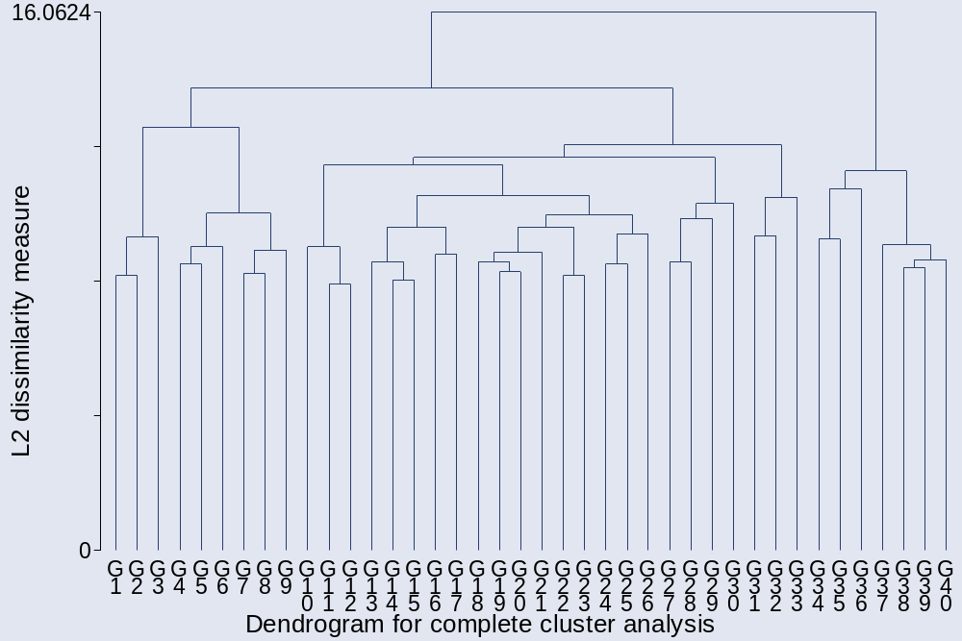

Above is the dendrogram showing 40 clusters.

. cluster stop
+---------------------------+
| | Calinski/ |
| Number of | Harabasz |
| clusters | pseudo-F |
|-------------+-------------|
| 2 | 152.75 |
| 3 | 115.39 |
| 4 | 81.75 |
| 5 | 65.12 |
| 6 | 69.83 |
| 7 | 61.87 |
| 8 | 56.18 |
| 9 | 50.00 |
| 10 | 52.58 |
| 11 | 47.83 |
| 12 | 47.17 |
| 13 | 44.21 |
| 14 | 44.27 |
| 15 | 42.40 |
+---------------------------+

. cluster stop, rule (duda)
+-----------------------------------------+
| | Duda/Hart |
| Number of | | pseudo |
| clusters | Je(2)/Je(1) | T-squared |
|-------------+-------------+-------------|
| 1 | 0.8579 | 152.75 |
| 2 | 0.9271 | 68.32 |
| 3 | 0.8546 | 10.21 |
| 4 | 0.9846 | 12.64 |
| 5 | 0.9139 | 72.62 |
| 6 | 0.9723 | 17.07 |
| 7 | 0.7929 | 13.32 |
| 8 | 0.8137 | 5.26 |
| 9 | 0.9123 | 55.06 |
| 10 | 0.8967 | 3.92 |
| 11 | 0.8497 | 30.07 |
| 12 | 0.8752 | 6.27 |
| 13 | 0.9152 | 30.40 |
| 14 | 0.8868 | 11.24 |
+-----------------------------------------+

The stopping rules does not really give strong advice on how many groups to create: I did 2-5 (the commands that follow below).

. cluster gen gcom2=group(2)
. cluster gen gcom3=group(3)
. cluster gen gcom4=group(4)
. cluster gen gcom5=group(5)
. cluster gen gcom6=group(6)

Below are the means of the 18 items when dividing the data into two groups, each item starts with nu (“now” in Swedish) and then names that hopefully reveals the policy item. Nutariff is the variable that records respondents present views on tariffs; the survey also asked the respondent to provide the view she had when she was 25 years old, and that data is not used here or in the Critical Review paper. Lower means indicate support of a policy item, 3 indicates “have mixed feelings” and high means indicate opposition to the government activism.

Two groups:

. bysort gcom2: sum nu*
_______________________________________________________________________________
-> gcom2 = 1

Variable | Obs Mean Std. Dev. Min Max
-------------+--------------------------------------------------------
nutariff | 871 3.544202 1.195801 1 5
numinw | 871 1.404133 .8641953 1 5
nuOSHA | 871 1.235362 .5640075 1 4
nuFDA | 871 1.311137 .6666799 1 5
nuEPA | 871 1.163031 .4780824 1 4
-------------+--------------------------------------------------------
nudisc | 871 1.28473 .7423068 1 5
nudrugs | 871 2.291619 1.317403 1 5
nuprost | 871 3.051665 1.233011 1 5
nugambl | 871 2.717566 1.2805 1 5
nuguns | 871 1.461538 .9663663 1 5
-------------+--------------------------------------------------------
nugovown | 871 3.250287 1.306675 1 5
nuredist | 871 1.490241 .9145485 1 5
nuschool | 871 1.577497 1.029741 1 5
numonet | 871 1.986223 .9083487 1 5
nufisc | 871 1.973594 .9348874 1 5
-------------+--------------------------------------------------------
nuimmi | 871 3.423651 1.385754 1 5
numilaid | 871 3.366246 1.373881 1 5
nuWB | 871 2.080367 1.210288 1 5

_______________________________________________________________________________
-> gcom2 = 2

Variable | Obs Mean Std. Dev. Min Max
-------------+--------------------------------------------------------
nutariff | 53 4.792453 .6311921 1 5
numinw | 53 4.54717 .6065678 3 5
nuOSHA | 53 3.490566 1.153967 1 5
nuFDA | 53 3.528302 1.367251 1 5
nuEPA | 53 3.245283 1.238884 1 5
-------------+--------------------------------------------------------
nudisc | 53 3.150943 1.485782 1 5
nudrugs | 53 3.735849 1.242685 1 5
nuprost | 53 4.264151 .9637855 1 5
nugambl | 53 4.264151 1.002899 1 5
nuguns | 53 4.207547 1.198693 1 5
-------------+--------------------------------------------------------
nugovown | 53 4.867925 .4401807 3 5
nuredist | 53 3.735849 1.258065 1 5
nuschool | 53 3.54717 1.338283 1 5
numonet | 53 3.09434 1.390409 1 5
nufisc | 53 4.09434 1.078891 2 5
-------------+--------------------------------------------------------
nuimmi | 53 3.396226 1.497942 1 5
numilaid | 53 2.886792 1.339638 1 5
nuWB | 53 3.528302 1.218507 1 5

Those with missing values (note that the number of Obs vary):
_______________________________________________________________________________
-> gcom2 = .

Variable | Obs Mean Std. Dev. Min Max
-------------+--------------------------------------------------------
nutariff | 268 3.526119 1.142992 1 5
numinw | 281 1.24911 .6880674 1 5
nuOSHA | 280 1.192857 .5273377 1 4
nuFDA | 276 1.300725 .7033423 1 5
nuEPA | 279 1.111111 .4048072 1 4
-------------+--------------------------------------------------------
nudisc | 281 1.288256 .7737923 1 5
nudrugs | 272 2.360294 1.334597 1 5
nuprost | 257 3.124514 1.218374 1 5
nugambl | 243 2.580247 1.238476 1 5
nuguns | 276 1.387681 .9371487 1 5
-------------+--------------------------------------------------------
nugovown | 249 3.305221 1.219471 1 5
nuredist | 253 1.403162 .7839599 1 5
nuschool | 166 1.644578 1.201086 1 5
numonet | 206 2.082524 .9149093 1 5
nufisc | 206 2.024272 .9445057 1 5
-------------+--------------------------------------------------------
nuimmi | 280 3.517857 1.362465 1 5
numilaid | 264 3.450758 1.391664 1 5
nuWB | 274 2.080292 1.155071 1 5

There are quite a few people who have indicated “no opinion” on monetary and fiscal policy, and even more people who did not respond to the public school question. That is why we exclude these three items in alternative specifications using the same clustering technique, including the analyses presented in the Critical Review piece.

Three groups:

. bysort gcom3: sum nu*
____________________________________________________________________________
-> gcom3 = 1

Variable | Obs Mean Std. Dev. Min Max
-------------+--------------------------------------------------------
nutariff | 62 3.225806 1.419066 1 5
numinw | 62 2.822581 1.349246 1 5
nuOSHA | 62 2.177419 .8967006 1 4
nuFDA | 62 2.064516 1.038141 1 5
nuEPA | 62 2.032258 .9575882 1 4
-------------+--------------------------------------------------------
nudisc | 62 2.258065 1.158511 1 5
nudrugs | 62 1.725806 1.269689 1 5
nuprost | 62 2.532258 1.327116 1 5
nugambl | 62 2.548387 1.478562 1 5
nuguns | 62 2.870968 1.442719 1 5
-------------+--------------------------------------------------------
nugovown | 62 4.467742 .9359442 1 5
nuredist | 62 3.483871 1.237951 1 5
nuschool | 62 2.790323 1.307445 1 5
numonet | 62 2.193548 .9204188 1 4
nufisc | 62 2.387097 .9641923 1 5
-------------+--------------------------------------------------------
nuimmi | 62 1.983871 1.207788 1 5
numilaid | 62 1.951613 1.046891 1 5
nuWB | 62 2.241935 .9527438 1 4

_______________________________________________________________________________
-> gcom3 = 2

Variable | Obs Mean Std. Dev. Min Max
-------------+--------------------------------------------------------
nutariff | 809 3.568603 1.174419 1 5
numinw | 809 1.295426 .7074507 1 5
nuOSHA | 809 1.163164 .4566103 1 4
nuFDA | 809 1.253399 .5918727 1 5
nuEPA | 809 1.096415 .3383119 1 4
-------------+--------------------------------------------------------
nudisc | 809 1.210136 .6432022 1 5
nudrugs | 809 2.334981 1.311705 1 5
nuprost | 809 3.091471 1.21726 1 5
nugambl | 809 2.730532 1.264155 1 5
nuguns | 809 1.353523 .8272079 1 5
-------------+--------------------------------------------------------
nugovown | 809 3.156984 1.284457 1 5
nuredist | 809 1.337454 .675669 1 5
nuschool | 809 1.484549 .9440124 1 5
numonet | 809 1.970334 .9060359 1 5
nufisc | 809 1.941904 .9256182 1 5
-------------+--------------------------------------------------------
nuimmi | 809 3.533993 1.336518 1 5
numilaid | 809 3.47466 1.335784 1 5
nuWB | 809 2.067985 1.2274 1 5

_______________________________________________________________________________
-> gcom3 = 3

Variable | Obs Mean Std. Dev. Min Max
-------------+--------------------------------------------------------
nutariff | 53 4.792453 .6311921 1 5
numinw | 53 4.54717 .6065678 3 5
nuOSHA | 53 3.490566 1.153967 1 5
nuFDA | 53 3.528302 1.367251 1 5
nuEPA | 53 3.245283 1.238884 1 5
-------------+--------------------------------------------------------
nudisc | 53 3.150943 1.485782 1 5
nudrugs | 53 3.735849 1.242685 1 5
nuprost | 53 4.264151 .9637855 1 5
nugambl | 53 4.264151 1.002899 1 5
nuguns | 53 4.207547 1.198693 1 5
-------------+--------------------------------------------------------
nugovown | 53 4.867925 .4401807 3 5
nuredist | 53 3.735849 1.258065 1 5
nuschool | 53 3.54717 1.338283 1 5
numonet | 53 3.09434 1.390409 1 5
nufisc | 53 4.09434 1.078891 2 5
-------------+--------------------------------------------------------
nuimmi | 53 3.396226 1.497942 1 5
numilaid | 53 2.886792 1.339638 1 5
nuWB | 53 3.528302 1.218507 1 5

Those with missing values: _______________________________________________________________________________
-> gcom3 = .

Variable | Obs Mean Std. Dev. Min Max
-------------+--------------------------------------------------------
nutariff | 268 3.526119 1.142992 1 5
numinw | 281 1.24911 .6880674 1 5
nuOSHA | 280 1.192857 .5273377 1 4
nuFDA | 276 1.300725 .7033423 1 5
nuEPA | 279 1.111111 .4048072 1 4
-------------+--------------------------------------------------------
nudisc | 281 1.288256 .7737923 1 5
nudrugs | 272 2.360294 1.334597 1 5
nuprost | 257 3.124514 1.218374 1 5
nugambl | 243 2.580247 1.238476 1 5
nuguns | 276 1.387681 .9371487 1 5
-------------+--------------------------------------------------------
nugovown | 249 3.305221 1.219471 1 5
nuredist | 253 1.403162 .7839599 1 5
nuschool | 166 1.644578 1.201086 1 5
numonet | 206 2.082524 .9149093 1 5
nufisc | 206 2.024272 .9445057 1 5
-------------+--------------------------------------------------------
nuimmi | 280 3.517857 1.362465 1 5
numilaid | 264 3.450758 1.391664 1 5
nuWB | 274 2.080292 1.155071 1 5

Four groups:

_______________________________________________________________________________
-> gcom4 = 1

Variable | Obs Mean Std. Dev. Min Max
-------------+--------------------------------------------------------
nutariff | 16 2.8125 1.424488 1 5
numinw | 16 3.125 1.408309 1 5
nuOSHA | 16 1.875 .8062258 1 3
nuFDA | 16 1.5625 .7274384 1 3
nuEPA | 16 1.5625 .6291529 1 3
-------------+--------------------------------------------------------
nudisc | 16 2.125 1.024695 1 4
nudrugs | 16 2.9375 1.842779 1 5
nuprost | 16 4.3125 .7932003 3 5
nugambl | 16 4.5625 .7274384 3 5
nuguns | 16 2.875 1.408309 1 5
-------------+--------------------------------------------------------
nugovown | 16 4.125 1.087811 2 5
nuredist | 16 3.5 1.505545 1 5
nuschool | 16 2.3125 1.352467 1 5
numonet | 16 2.3125 1.138347 1 4
nufisc | 16 2.0625 .8539126 1 3
-------------+--------------------------------------------------------
nuimmi | 16 1.8125 1.167262 1 4
numilaid | 16 1.625 1.024695 1 4
nuWB | 16 1.875 .7187953 1 3

_______________________________________________________________________________
-> gcom4 = 2

Variable | Obs Mean Std. Dev. Min Max
-------------+--------------------------------------------------------
nutariff | 46 3.369565 1.4041 1 5
numinw | 46 2.717391 1.327706 1 5
nuOSHA | 46 2.282609 .9107517 1 4
nuFDA | 46 2.23913 1.078781 1 5
nuEPA | 46 2.195652 1.002653 1 4
-------------+--------------------------------------------------------
nudisc | 46 2.304348 1.208664 1 5
nudrugs | 46 1.304348 .5914038 1 3
nuprost | 46 1.913043 .8117495 1 4
nugambl | 46 1.847826 .9181477 1 4
nuguns | 46 2.869565 1.469825 1 5
-------------+--------------------------------------------------------
nugovown | 46 4.586957 .858321 1 5
nuredist | 46 3.478261 1.149669 1 5
nuschool | 46 2.956522 1.264147 1 5
numonet | 46 2.152174 .8424143 1 4
nufisc | 46 2.5 .9831921 1 5
-------------+--------------------------------------------------------
nuimmi | 46 2.043478 1.228486 1 5
numilaid | 46 2.065217 1.041413 1 5
nuWB | 46 2.369565 .996855 1 4

_______________________________________________________________________________
-> gcom4 = 3

Variable | Obs Mean Std. Dev. Min Max
-------------+--------------------------------------------------------
nutariff | 809 3.568603 1.174419 1 5
numinw | 809 1.295426 .7074507 1 5
nuOSHA | 809 1.163164 .4566103 1 4
nuFDA | 809 1.253399 .5918727 1 5
nuEPA | 809 1.096415 .3383119 1 4
-------------+--------------------------------------------------------
nudisc | 809 1.210136 .6432022 1 5
nudrugs | 809 2.334981 1.311705 1 5
nuprost | 809 3.091471 1.21726 1 5
nugambl | 809 2.730532 1.264155 1 5
nuguns | 809 1.353523 .8272079 1 5
-------------+--------------------------------------------------------
nugovown | 809 3.156984 1.284457 1 5
nuredist | 809 1.337454 .675669 1 5
nuschool | 809 1.484549 .9440124 1 5
numonet | 809 1.970334 .9060359 1 5
nufisc | 809 1.941904 .9256182 1 5
-------------+--------------------------------------------------------
nuimmi | 809 3.533993 1.336518 1 5
numilaid | 809 3.47466 1.335784 1 5
nuWB | 809 2.067985 1.2274 1 5

_______________________________________________________________________________
-> gcom4 = 4

Variable | Obs Mean Std. Dev. Min Max
-------------+--------------------------------------------------------
nutariff | 53 4.792453 .6311921 1 5
numinw | 53 4.54717 .6065678 3 5
nuOSHA | 53 3.490566 1.153967 1 5
nuFDA | 53 3.528302 1.367251 1 5
nuEPA | 53 3.245283 1.238884 1 5
-------------+--------------------------------------------------------
nudisc | 53 3.150943 1.485782 1 5
nudrugs | 53 3.735849 1.242685 1 5
nuprost | 53 4.264151 .9637855 1 5
nugambl | 53 4.264151 1.002899 1 5
nuguns | 53 4.207547 1.198693 1 5
-------------+--------------------------------------------------------
nugovown | 53 4.867925 .4401807 3 5
nuredist | 53 3.735849 1.258065 1 5
nuschool | 53 3.54717 1.338283 1 5
numonet | 53 3.09434 1.390409 1 5
nufisc | 53 4.09434 1.078891 2 5
-------------+--------------------------------------------------------
nuimmi | 53 3.396226 1.497942 1 5
numilaid | 53 2.886792 1.339638 1 5
nuWB | 53 3.528302 1.218507 1 5

Those with missing values:
_______________________________________________________________________________
-> gcom4 = .

Variable | Obs Mean Std. Dev. Min Max
-------------+--------------------------------------------------------
nutariff | 268 3.526119 1.142992 1 5
numinw | 281 1.24911 .6880674 1 5
nuOSHA | 280 1.192857 .5273377 1 4
nuFDA | 276 1.300725 .7033423 1 5
nuEPA | 279 1.111111 .4048072 1 4
-------------+--------------------------------------------------------
nudisc | 281 1.288256 .7737923 1 5
nudrugs | 272 2.360294 1.334597 1 5
nuprost | 257 3.124514 1.218374 1 5
nugambl | 243 2.580247 1.238476 1 5
nuguns | 276 1.387681 .9371487 1 5
-------------+--------------------------------------------------------
nugovown | 249 3.305221 1.219471 1 5
nuredist | 253 1.403162 .7839599 1 5
nuschool | 166 1.644578 1.201086 1 5
numonet | 206 2.082524 .9149093 1 5
nufisc | 206 2.024272 .9445057 1 5
-------------+--------------------------------------------------------
nuimmi | 280 3.517857 1.362465 1 5
numilaid | 264 3.450758 1.391664 1 5
nuWB | 274 2.080292 1.155071 1 5

Five groups:

. bysort gcom5: sum nu*
______________________________________________________________________________
-> gcom5 = 1

Variable | Obs Mean Std. Dev. Min Max
-------------+--------------------------------------------------------
nutariff | 16 2.8125 1.424488 1 5
numinw | 16 3.125 1.408309 1 5
nuOSHA | 16 1.875 .8062258 1 3
nuFDA | 16 1.5625 .7274384 1 3
nuEPA | 16 1.5625 .6291529 1 3
-------------+--------------------------------------------------------
nudisc | 16 2.125 1.024695 1 4
nudrugs | 16 2.9375 1.842779 1 5
nuprost | 16 4.3125 .7932003 3 5
nugambl | 16 4.5625 .7274384 3 5
nuguns | 16 2.875 1.408309 1 5
-------------+--------------------------------------------------------
nugovown | 16 4.125 1.087811 2 5
nuredist | 16 3.5 1.505545 1 5
nuschool | 16 2.3125 1.352467 1 5
numonet | 16 2.3125 1.138347 1 4
nufisc | 16 2.0625 .8539126 1 3
-------------+--------------------------------------------------------
nuimmi | 16 1.8125 1.167262 1 4
numilaid | 16 1.625 1.024695 1 4
nuWB | 16 1.875 .7187953 1 3

_______________________________________________________________________________
-> gcom5 = 2

Variable | Obs Mean Std. Dev. Min Max
-------------+--------------------------------------------------------
nutariff | 46 3.369565 1.4041 1 5
numinw | 46 2.717391 1.327706 1 5
nuOSHA | 46 2.282609 .9107517 1 4
nuFDA | 46 2.23913 1.078781 1 5
nuEPA | 46 2.195652 1.002653 1 4
-------------+--------------------------------------------------------
nudisc | 46 2.304348 1.208664 1 5
nudrugs | 46 1.304348 .5914038 1 3
nuprost | 46 1.913043 .8117495 1 4
nugambl | 46 1.847826 .9181477 1 4
nuguns | 46 2.869565 1.469825 1 5
-------------+--------------------------------------------------------
nugovown | 46 4.586957 .858321 1 5
nuredist | 46 3.478261 1.149669 1 5
nuschool | 46 2.956522 1.264147 1 5
numonet | 46 2.152174 .8424143 1 4
nufisc | 46 2.5 .9831921 1 5
-------------+--------------------------------------------------------
nuimmi | 46 2.043478 1.228486 1 5
numilaid | 46 2.065217 1.041413 1 5
nuWB | 46 2.369565 .996855 1 4

_______________________________________________________________________________
-> gcom5 = 3

Variable | Obs Mean Std. Dev. Min Max
-------------+--------------------------------------------------------
nutariff | 773 3.627426 1.14872 1 5
numinw | 773 1.298836 .7143686 1 5
nuOSHA | 773 1.164295 .461096 1 4
nuFDA | 773 1.249677 .58124 1 5
nuEPA | 773 1.094437 .3378269 1 4
-------------+--------------------------------------------------------
nudisc | 773 1.206986 .6325398 1 5
nudrugs | 773 2.3674 1.318294 1 5
nuprost | 773 3.119017 1.220003 1 5
nugambl | 773 2.771022 1.266585 1 5
nuguns | 773 1.359638 .8363664 1 5
-------------+--------------------------------------------------------
nugovown | 773 3.143596 1.291192 1 5
nuredist | 773 1.31436 .634307 1 5
nuschool | 773 1.454075 .8958885 1 5
numonet | 773 1.918499 .8696565 1 5
nufisc | 773 1.917206 .9209009 1 5
-------------+--------------------------------------------------------
nuimmi | 773 3.522639 1.342246 1 5
numilaid | 773 3.465718 1.349698 1 5
nuWB | 773 2.037516 1.229975 1 5

_______________________________________________________________________________
-> gcom5 = 4

Variable | Obs Mean Std. Dev. Min Max
-------------+--------------------------------------------------------
nutariff | 36 2.305556 1.009086 1 5
numinw | 36 1.222222 .540429 1 3
nuOSHA | 36 1.138889 .3507362 1 2
nuFDA | 36 1.333333 .792825 1 5
nuEPA | 36 1.138889 .3507362 1 2
-------------+--------------------------------------------------------
nudisc | 36 1.277778 .8489022 1 5
nudrugs | 36 1.638889 .930523 1 4
nuprost | 36 2.5 1 1 5
nugambl | 36 1.861111 .8333333 1 4
nuguns | 36 1.222222 .5909368 1 3
-------------+--------------------------------------------------------
nugovown | 36 3.444444 1.106976 2 5
nuredist | 36 1.833333 1.183216 1 5
nuschool | 36 2.138889 1.552008 1 5
numonet | 36 3.083333 .9673233 2 5
nufisc | 36 2.472222 .8778581 1 5
-------------+--------------------------------------------------------
nuimmi | 36 3.777778 1.197882 1 5
numilaid | 36 3.666667 .9856108 1 5
nuWB | 36 2.722222 .9742722 1 5

_______________________________________________________________________________
-> gcom5 = 5

Variable | Obs Mean Std. Dev. Min Max
-------------+--------------------------------------------------------
nutariff | 53 4.792453 .6311921 1 5
numinw | 53 4.54717 .6065678 3 5
nuOSHA | 53 3.490566 1.153967 1 5
nuFDA | 53 3.528302 1.367251 1 5
nuEPA | 53 3.245283 1.238884 1 5
-------------+--------------------------------------------------------
nudisc | 53 3.150943 1.485782 1 5
nudrugs | 53 3.735849 1.242685 1 5
nuprost | 53 4.264151 .9637855 1 5
nugambl | 53 4.264151 1.002899 1 5
nuguns | 53 4.207547 1.198693 1 5
-------------+--------------------------------------------------------
nugovown | 53 4.867925 .4401807 3 5
nuredist | 53 3.735849 1.258065 1 5
nuschool | 53 3.54717 1.338283 1 5
numonet | 53 3.09434 1.390409 1 5
nufisc | 53 4.09434 1.078891 2 5
-------------+--------------------------------------------------------
nuimmi | 53 3.396226 1.497942 1 5
numilaid | 53 2.886792 1.339638 1 5
nuWB | 53 3.528302 1.218507 1 5

Those with missing values:
_____________________________________________________________________________
-> gcom5 = .

Variable | Obs Mean Std. Dev. Min Max
-------------+--------------------------------------------------------
nutariff | 268 3.526119 1.142992 1 5
numinw | 281 1.24911 .6880674 1 5
nuOSHA | 280 1.192857 .5273377 1 4
nuFDA | 276 1.300725 .7033423 1 5
nuEPA | 279 1.111111 .4048072 1 4
-------------+--------------------------------------------------------
nudisc | 281 1.288256 .7737923 1 5
nudrugs | 272 2.360294 1.334597 1 5
nuprost | 257 3.124514 1.218374 1 5
nugambl | 243 2.580247 1.238476 1 5
nuguns | 276 1.387681 .9371487 1 5
-------------+--------------------------------------------------------
nugovown | 249 3.305221 1.219471 1 5
nuredist | 253 1.403162 .7839599 1 5
nuschool | 166 1.644578 1.201086 1 5
numonet | 206 2.082524 .9149093 1 5
nufisc | 206 2.024272 .9445057 1 5
-------------+--------------------------------------------------------

nuimmi | 280 3.517857 1.362465 1 5
numilaid | 264 3.450758 1.391664 1 5
nuWB | 274 2.080292 1.155071 1 5

Six groups:

. bysort gcom6: sum nu*

_______________________________________________________________________________
-> gcom6 = 1

Variable | Obs Mean Std. Dev. Min Max
-------------+--------------------------------------------------------
nutariff | 16 2.8125 1.424488 1 5
numinw | 16 3.125 1.408309 1 5
nuOSHA | 16 1.875 .8062258 1 3
nuFDA | 16 1.5625 .7274384 1 3
nuEPA | 16 1.5625 .6291529 1 3
-------------+--------------------------------------------------------
nudisc | 16 2.125 1.024695 1 4
nudrugs | 16 2.9375 1.842779 1 5
nuprost | 16 4.3125 .7932003 3 5
nugambl | 16 4.5625 .7274384 3 5
nuguns | 16 2.875 1.408309 1 5

-------------+--------------------------------------------------------
nugovown | 16 4.125 1.087811 2 5
nuredist | 16 3.5 1.505545 1 5
nuschool | 16 2.3125 1.352467 1 5
numonet | 16 2.3125 1.138347 1 4
nufisc | 16 2.0625 .8539126 1 3
-------------+--------------------------------------------------------
nuimmi | 16 1.8125 1.167262 1 4
numilaid | 16 1.625 1.024695 1 4
nuWB | 16 1.875 .7187953 1 3

_______________________________________________________________________________
-> gcom6 = 2

Variable | Obs Mean Std. Dev. Min Max
-------------+--------------------------------------------------------
nutariff | 46 3.369565 1.4041 1 5
numinw | 46 2.717391 1.327706 1 5
nuOSHA | 46 2.282609 .9107517 1 4
nuFDA | 46 2.23913 1.078781 1 5
nuEPA | 46 2.195652 1.002653 1 4
-------------+--------------------------------------------------------
nudisc | 46 2.304348 1.208664 1 5
nudrugs | 46 1.304348 .5914038 1 3
nuprost | 46 1.913043 .8117495 1 4
nugambl | 46 1.847826 .9181477 1 4
nuguns | 46 2.869565 1.469825 1 5
-------------+--------------------------------------------------------
nugovown | 46 4.586957 .858321 1 5
nuredist | 46 3.478261 1.149669 1 5
nuschool | 46 2.956522 1.264147 1 5
numonet | 46 2.152174 .8424143 1 4
nufisc | 46 2.5 .9831921 1 5
-------------+--------------------------------------------------------
nuimmi | 46 2.043478 1.228486 1 5
numilaid | 46 2.065217 1.041413 1 5
nuWB | 46 2.369565 .996855 1 4

_______________________________________________________________________________
-> gcom6 = 3

Variable | Obs Mean Std. Dev. Min Max
-------------+--------------------------------------------------------
nutariff | 601 3.682196 1.116766 1 5
numinw | 601 1.309484 .7076204 1 5
nuOSHA | 601 1.174709 .4702049 1 4
nuFDA | 601 1.241265 .5627561 1 4
nuEPA | 601 1.096506 .3473775 1 4
-------------+--------------------------------------------------------
nudisc | 601 1.246256 .6946871 1 5
nudrugs | 601 1.9401 1.078458 1 5
nuprost | 601 2.856905 1.161675 1 5
nugambl | 601 2.565724 1.206685 1 5
nuguns | 601 1.331115 .7906834 1 5
-------------+--------------------------------------------------------
nugovown | 601 3.327787 1.229109 1 5
nuredist | 601 1.359401 .6737574 1 5
nuschool | 601 1.514143 .9505523 1 5
numonet | 601 1.8802 .85379 1 5
nufisc | 601 1.896839 .8790184 1 5
-------------+--------------------------------------------------------
nuimmi | 601 3.381032 1.342723 1 5
numilaid | 601 3.294509 1.358229 1 5
nuWB | 601 1.805324 1.063189 1 5

_______________________________________________________________________________
-> gcom6 = 4

Variable | Obs Mean Std. Dev. Min Max
-------------+--------------------------------------------------------
nutariff | 172 3.436047 1.238506 1 5
numinw | 172 1.261628 .7383669 1 5
nuOSHA | 172 1.127907 .4270533 1 4
nuFDA | 172 1.27907 .6425673 1 5
nuEPA | 172 1.087209 .3029278 1 3
-------------+--------------------------------------------------------
nudisc | 172 1.069767 .2977773 1 3
nudrugs | 172 3.860465 .9386165 1 5
nuprost | 172 4.034884 .9483464 1 5
nugambl | 172 3.488372 1.211487 1 5
nuguns | 172 1.459302 .9754744 1 5
-------------+--------------------------------------------------------
nugovown | 172 2.5 1.300022 1 5
nuredist | 172 1.156977 .4377082 1 3
nuschool | 172 1.244186 .6294163 1 4
numonet | 172 2.052326 .912964 1 5
nufisc | 172 1.988372 1.054028 1 5
-------------+--------------------------------------------------------
nuimmi | 172 4.017442 1.221033 1 5
numilaid | 172 4.063953 1.135026 1 5
nuWB | 172 2.848837 1.418486 1 5

_______________________________________________________________________________
-> gcom6 = 5

Variable | Obs Mean Std. Dev. Min Max
-------------+--------------------------------------------------------
nutariff | 36 2.305556 1.009086 1 5
numinw | 36 1.222222 .540429 1 3
nuOSHA | 36 1.138889 .3507362 1 2
nuFDA | 36 1.333333 .792825 1 5
nuEPA | 36 1.138889 .3507362 1 2
-------------+--------------------------------------------------------
nudisc | 36 1.277778 .8489022 1 5
nudrugs | 36 1.638889 .930523 1 4
nuprost | 36 2.5 1 1 5
nugambl | 36 1.861111 .8333333 1 4
nuguns | 36 1.222222 .5909368 1 3
-------------+--------------------------------------------------------
nugovown | 36 3.444444 1.106976 2 5
nuredist | 36 1.833333 1.183216 1 5
nuschool | 36 2.138889 1.552008 1 5
numonet | 36 3.083333 .9673233 2 5
nufisc | 36 2.472222 .8778581 1 5
-------------+--------------------------------------------------------
nuimmi | 36 3.777778 1.197882 1 5
numilaid | 36 3.666667 .9856108 1 5
nuWB | 36 2.722222 .9742722 1 5

_______________________________________________________________________________
-> gcom6 = 6

Variable | Obs Mean Std. Dev. Min Max
-------------+--------------------------------------------------------
nutariff | 53 4.792453 .6311921 1 5
numinw | 53 4.54717 .6065678 3 5
nuOSHA | 53 3.490566 1.153967 1 5
nuFDA | 53 3.528302 1.367251 1 5
nuEPA | 53 3.245283 1.238884 1 5
-------------+--------------------------------------------------------
nudisc | 53 3.150943 1.485782 1 5
nudrugs | 53 3.735849 1.242685 1 5
nuprost | 53 4.264151 .9637855 1 5
nugambl | 53 4.264151 1.002899 1 5
nuguns | 53 4.207547 1.198693 1 5
-------------+--------------------------------------------------------
nugovown | 53 4.867925 .4401807 3 5
nuredist | 53 3.735849 1.258065 1 5
nuschool | 53 3.54717 1.338283 1 5
numonet | 53 3.09434 1.390409 1 5
nufisc | 53 4.09434 1.078891 2 5
-------------+--------------------------------------------------------
nuimmi | 53 3.396226 1.497942 1 5
numilaid | 53 2.886792 1.339638 1 5
nuWB | 53 3.528302 1.218507 1 5

Those with missing values:
_______________________________________________________________________________
-> gcom6 = .

Variable | Obs Mean Std. Dev. Min Max
-------------+--------------------------------------------------------
nutariff | 268 3.526119 1.142992 1 5
numinw | 281 1.24911 .6880674 1 5
nuOSHA | 280 1.192857 .5273377 1 4
nuFDA | 276 1.300725 .7033423 1 5
nuEPA | 279 1.111111 .4048072 1 4
-------------+--------------------------------------------------------
nudisc | 281 1.288256 .7737923 1 5
nudrugs | 272 2.360294 1.334597 1 5
nuprost | 257 3.124514 1.218374 1 5
nugambl | 243 2.580247 1.238476 1 5
nuguns | 276 1.387681 .9371487 1 5
-------------+--------------------------------------------------------
nugovown | 249 3.305221 1.219471 1 5
nuredist | 253 1.403162 .7839599 1 5
nuschool | 166 1.644578 1.201086 1 5
numonet | 206 2.082524 .9149093 1 5
nufisc | 206 2.024272 .9445057 1 5
-------------+--------------------------------------------------------
nuimmi | 280 3.517857 1.362465 1 5
numilaid | 264 3.450758 1.391664 1 5
nuWB | 274 2.080292 1.155071 1 5

Here is the same analysis as above, using the same subsample of the data (all policy items), but using the Average Linkage cluster technique:

. cluster averagelinkage nu*

cluster name: _cl_1

. cluster tree, vertlab cutnumber (40)

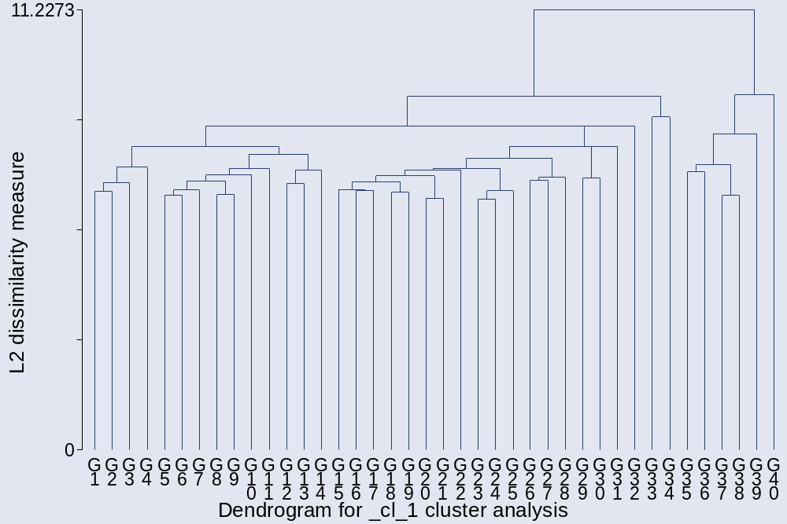

. cluster stop
+---------------------------+
| | Calinski/ |
| Number of | Harabasz |
| clusters | pseudo-F |
|-------------+-------------|
| 2 | 133.00 |
| 3 | 68.21 |
| 4 | 47.04 |
| 5 | 35.75 |
| 6 | 46.96 |
| 7 | 39.65 |
| 8 | 34.69 |
| 9 | 30.86 |
| 10 | 28.06 |
| 11 | 26.77 |
| 12 | 24.66 |
| 13 | 24.65 |
| 14 | 23.04 |
| 15 | 21.72 |
+---------------------------+

. cluster stop, rule (duda)

+-----------------------------------------+
| | Duda/Hart |
| Number of | | pseudo |
| clusters | Je(2)/Je(1) | T-squared |
|-------------+-------------+-------------|
| 1 | 0.8739 | 133.00 |
| 2 | 0.8919 | 3.64 |
| 3 | 0.9953 | 4.21 |
| 4 | 0.0000 | . |
| 5 | 0.9179 | 79.40 |
| 6 | 0.9967 | 2.74 |
| 7 | 0.8527 | 5.01 |
| 8 | 0.9958 | 3.50 |
| 9 | 0.9943 | 4.73 |
| 10 | 0.8616 | 9.80 |
| 11 | 0.9447 | 2.52 |
| 12 | 0.9769 | 19.35 |
| 13 | 0.8710 | 4.00 |
| 14 | 0.8284 | 3.32 |
| 15 | 0.9891 | 8.85 |
+-----------------------------------------+

The Duda/Hart rule suggest 6 groups, so I skip the first divisions and create six groups:

. cluster gen gav6=group (6)
. bysort gav6: sum nu*
_______________________________________________________________________________
-> gav6 = 1

Variable | Obs Mean Std. Dev. Min Max
-------------+--------------------------------------------------------
nutariff | 63 4.206349 1.309503 1 5
numinw | 63 3.587302 1.144903 1 5
nuOSHA | 63 2.507937 .8399888 1 4
nuFDA | 63 2.428571 1.13186 1 5
nuEPA | 63 2.349206 .9698475 1 5
-------------+--------------------------------------------------------
nudisc | 63 2.365079 1.347657 1 5
nudrugs | 63 2.111111 1.321181 1 5
nuprost | 63 3.126984 1.301266 1 5
nugambl | 63 3.126984 1.385315 1 5
nuguns | 63 3.015873 1.475521 1 5
-------------+--------------------------------------------------------
nugovown | 63 4.746032 .5948232 3 5
nuredist | 63 3.285714 1.312822 1 5
nuschool | 63 2.666667 1.270001 1 5
numonet | 63 2.365079 1.082136 1 5
nufisc | 63 3.095238 1.200998 1 5
-------------+--------------------------------------------------------
nuimmi | 63 2.650794 1.449791 1 5
numilaid | 63 2.253968 1.163535 1 5
nuWB | 63 2.603175 1.055549 1 5

_______________________________________________________________________________
-> gav6 = 2

Variable | Obs Mean Std. Dev. Min Max
-------------+--------------------------------------------------------
nutariff | 827 3.525998 1.177982 1 5
numinw | 827 1.310762 .7291361 1 5
nuOSHA | 827 1.172914 .4697551 1 4
nuFDA | 827 1.249093 .5660778 1 4
nuEPA | 827 1.10399 .3462998 1 4
-------------+--------------------------------------------------------
nudisc | 827 1.233374 .6601406 1 5
nudrugs | 827 2.3289 1.320604 1 5
nuprost | 827 3.068924 1.229713 1 5
nugambl | 827 2.71705 1.273586 1 5
nuguns | 827 1.384522 .8605716 1 5
-------------+--------------------------------------------------------
nugovown | 827 3.172914 1.287993 1 5
nuredist | 827 1.385732 .75107 1 5
nuschool | 827 1.505441 .9495287 1 5
numonet | 827 1.967352 .8966703 1 5
nufisc | 827 1.929867 .9032711 1 5
-------------+--------------------------------------------------------
nuimmi | 827 3.478839 1.36205 1 5
numilaid | 827 3.423216 1.352907 1 5
nuWB | 827 2.047158 1.204894 1 5

_______________________________________________________________________________
-> gav6 = 3

Variable | Obs Mean Std. Dev. Min Max
-------------+--------------------------------------------------------
nutariff | 1 4 . 4 4
numinw | 1 1 . 1 1
nuOSHA | 1 1 . 1 1
nuFDA | 1 5 . 5 5
nuEPA | 1 1 . 1 1
-------------+--------------------------------------------------------
nudisc | 1 1 . 1 1
nudrugs | 1 5 . 5 5
nuprost | 1 4 . 4 4
nugambl | 1 4 . 4 4
nuguns | 1 5 . 5 5
-------------+--------------------------------------------------------
nugovown | 1 5 . 5 5
nuredist | 1 2 . 2 2
nuschool | 1 1 . 1 1
numonet | 1 3 . 3 3
nufisc | 1 3 . 3 3
-------------+--------------------------------------------------------
nuimmi | 1 5 . 5 5
numilaid | 1 5 . 5 5
nuWB | 1 5 . 5 5

_______________________________________________________________________________
-> gav6 = 4

Variable | Obs Mean Std. Dev. Min Max
-------------+--------------------------------------------------------
nutariff | 1 5 . 5 5

numinw | 1 1 . 1 1
nuOSHA | 1 1 . 1 1
nuFDA | 1 5 . 5 5
nuEPA | 1 1 . 1 1
-------------+--------------------------------------------------------
nudisc | 1 1 . 1 1
nudrugs | 1 1 . 1 1
nuprost | 1 5 . 5 5
nugambl | 1 1 . 1 1
nuguns | 1 1 . 1 1
-------------+--------------------------------------------------------
nugovown | 1 3 . 3 3
nuredist | 1 1 . 1 1
nuschool | 1 5 . 5 5
numonet | 1 5 . 5 5
nufisc | 1 5 . 5 5
-------------+--------------------------------------------------------
nuimmi | 1 5 . 5 5
numilaid | 1 5 . 5 5
nuWB | 1 5 . 5 5

_______________________________________________________________________________
-> gav6 = 5

A libertarian group:

Variable | Obs Mean Std. Dev. Min Max
-------------+--------------------------------------------------------
nutariff | 31 4.774194 .7620008 1 5
numinw | 31 4.741935 .4448027 4 5
nuOSHA | 31 4.16129 .77875 3 5
nuFDA | 31 4.258065 .8550923 3 5
nuEPA | 31 3.903226 .9435691 2 5
-------------+--------------------------------------------------------
nudisc | 31 3.677419 1.326326 1 5
nudrugs | 31 4 1.183216 1 5
nuprost | 31 4.387097 1.054433 1 5
nugambl | 31 4.483871 .9956896 1 5
nuguns | 31 4.83871 .3738783 4 5
-------------+--------------------------------------------------------
nugovown | 31 4.935484 .249731 4 5
nuredist | 31 4.354839 .9146361 2 5
nuschool | 31 4.451613 .7676245 2 5
numonet | 31 3.516129 1.338431 1 5
nufisc | 31 4.387097 .8823234 2 5
-------------+--------------------------------------------------------
nuimmi | 31 3.451613 1.567136 1 5
numilaid | 31 3.258065 1.413453 1 5
nuWB | 31 4.16129 .8980265 3 5

_______________________________________________________________________________
-> gav6 = 6

Variable | Obs Mean Std. Dev. Min Max
-------------+--------------------------------------------------------
nutariff | 1 3 . 3 3
numinw | 1 5 . 5 5
nuOSHA | 1 2 . 2 2
nuFDA | 1 1 . 1 1
nuEPA | 1 1 . 1 1
-------------+--------------------------------------------------------
nudisc | 1 1 . 1 1
nudrugs | 1 5 . 5 5
nuprost | 1 4 . 4 4
nugambl | 1 5 . 5 5
nuguns | 1 5 . 5 5
-------------+--------------------------------------------------------
nugovown | 1 5 . 5 5
nuredist | 1 5 . 5 5
nuschool | 1 5 . 5 5
numonet | 1 1 . 1 1
nufisc | 1 1 . 1 1
-------------+--------------------------------------------------------
nuimmi | 1 1 . 1 1
numilaid | 1 1 . 1 1
nuWB | 1 3 . 3 3

Those with missing values:
_______________________________________________________________________________
-> gav6 = .

Variable | Obs Mean Std. Dev. Min Max
-------------+--------------------------------------------------------
nutariff | 268 3.526119 1.142992 1 5
numinw | 281 1.24911 .6880674 1 5
nuOSHA | 280 1.192857 .5273377 1 4
nuFDA | 276 1.300725 .7033423 1 5
nuEPA | 279 1.111111 .4048072 1 4
-------------+--------------------------------------------------------
nudisc | 281 1.288256 .7737923 1 5
nudrugs | 272 2.360294 1.334597 1 5
nuprost | 257 3.124514 1.218374 1 5
nugambl | 243 2.580247 1.238476 1 5
nuguns | 276 1.387681 .9371487 1 5
-------------+--------------------------------------------------------
nugovown | 249 3.305221 1.219471 1 5
nuredist | 253 1.403162 .7839599 1 5
nuschool | 166 1.644578 1.201086 1 5
numonet | 206 2.082524 .9149093 1 5
nufisc | 206 2.024272 .9445057 1 5
-------------+--------------------------------------------------------
nuimmi | 280 3.517857 1.362465 1 5
numilaid | 264 3.450758 1.391664 1 5
nuWB | 274 2.080292 1.155071 1 5

Three of the six groups turn out not to really be groups, but the remaining three groups indicate a leftist group, a conservative group, and a libertarian group.

I go on to drop the three items with most missing values; schools, fiscal and monetary policy and run the Average Linkage cluster analyses again:

. drop nuschool nufisc numonet
. cluster averagelinkage nu*
cluster name: _cl_2

. cluster tree, vertlab cutnumber (40)
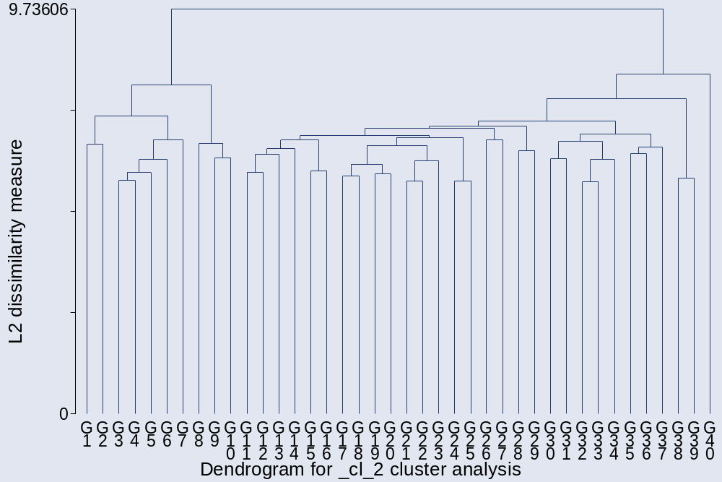

. cluster stop
+---------------------------+
| | Calinski/ |
| Number of | Harabasz |
| clusters | pseudo-F |
|-------------+-------------|
| 2 | 162.41 |
| 3 | 82.83 |
| 4 | 59.13 |
| 5 | 45.45 |
| 6 | 37.57 |
| 7 | 45.50 |
| 8 | 39.49 |
| 9 | 37.66 |
| 10 | 34.97 |
| 11 | 37.06 |
| 12 | 34.22 |
| 13 | 31.57 |
| 14 | 29.48 |
| 15 | 27.61 |
+---------------------------+

. cluster stop, rule (duda)

+-----------------------------------------+
| | Duda/Hart |
| Number of | | pseudo |
| clusters | Je(2)/Je(1) | T-squared |
|-------------+-------------+-------------|
| 1 | 0.8666 | 162.41 |
| 2 | 0.9970 | 2.99 |
| 3 | 0.8176 | 10.26 |
| 4 | 0.9961 | 3.94 |
| 5 | 0.8704 | 5.95 |
| 6 | 0.9328 | 72.28 |
| 7 | 0.9969 | 2.95 |
| 8 | 0.9789 | 20.13 |
| 9 | 0.8687 | 10.13 |
| 10 | 0.9546 | 43.64 |
| 11 | 0.9947 | 4.67 |
| 12 | 0.9461 | 2.05 |
| 13 | 0.7710 | 4.16 |
| 14 | 0.9451 | 2.38 |
| 15 | 0.8465 | 9.79 |
+-----------------------------------------+

. cluster gen gav22=group (2)
. cluster gen gav24=group (4)
. cluster gen gav27=group (7)

Two groups:

. bysort gav22: sum nu*
_____________________________________________________________________________
-> gav22 = 1

Variable | Obs Mean Std. Dev. Min Max
-------------+--------------------------------------------------------
nutariff | 48 4.6875 .7761402 1 5
numinw | 48 4.541667 .7706956 1 5
nuOSHA | 48 3.729167 .9836879 1 5
nuFDA | 48 3.958333 1.030561 1 5
nuEPA | 48 3.5625 1.070022 1 5
-------------+--------------------------------------------------------
nudisc | 48 3.4375 1.366876 1 5
nudrugs | 48 3.708333 1.428559 1 5
nuprost | 48 4.041667 1.336211 1 5
nugambl | 48 4.166667 1.310081 1 5
nuguns | 48 4.375 1.044234 1 5
-------------+--------------------------------------------------------
nugovown | 48 4.916667 .2793102 4 5
nuredist | 48 4.0625 1.060033 2 5
nuimmi | 48 3.208333 1.597316 1 5
numilaid | 48 2.729167 1.425297 1 5
nuWB | 48 3.541667 1.270924 1 5

_______________________________________________________________________________
-> gav22 = 2

Variable | Obs Mean Std. Dev. Min Max
-------------+--------------------------------------------------------
nutariff | 1009 3.55996 1.185487 1 5
numinw | 1009 1.392468 .8697876 1 5
nuOSHA | 1009 1.225966 .5441606 1 4
nuFDA | 1009 1.295342 .6439493 1 5
nuEPA | 1009 1.145689 .4359624 1 5
-------------+--------------------------------------------------------
nudisc | 1009 1.280476 .7357275 1 5
nudrugs | 1009 2.300297 1.314604 1 5
nuprost | 1009 3.071358 1.220226 1 5
nugambl | 1009 2.703667 1.263183 1 5
nuguns | 1009 1.451933 .9594552 1 5
-------------+--------------------------------------------------------
nugovown | 1009 3.269574 1.292022 1 5
nuredist | 1009 1.46779 .879215 1 5
nuimmi | 1009 3.451933 1.372895 1 5
numilaid | 1009 3.384539 1.368146 1 5
nuWB | 1009 2.083251 1.202266 1 5

Those with missing values:
_______________________________________________________________________________
-> gav22 = .

Variable | Obs Mean Std. Dev. Min Max
-------------+--------------------------------------------------------
nutariff | 135 3.474074 1.183403 1 5
numinw | 148 1.297297 .6747079 1 5
nuOSHA | 147 1.217687 .5912259 1 4
nuFDA | 143 1.335664 .7310426 1 5
nuEPA | 146 1.150685 .4747771 1 4
-------------+--------------------------------------------------------
nudisc | 148 1.290541 .7846606 1 5
nudrugs | 139 2.42446 1.340443 1 5
nuprost | 124 3.177419 1.262649 1 5
nugambl | 110 2.654545 1.323301 1 5
nuguns | 143 1.426573 1.003441 1 5
-------------+--------------------------------------------------------
nugovown | 116 3.25 1.264051 1 5
nuredist | 120 1.458333 .8391255 1 5
nuimmi | 147 3.469388 1.396209 1 5
numilaid | 131 3.435115 1.403837 1 5
nuWB | 141 2.106383 1.169262 1 5

Four groups:

. bysort gav24: sum nu*
______________________________________________________________________________
-> gav24 = 1

Variable | Obs Mean Std. Dev. Min Max
-------------+--------------------------------------------------------
nutariff | 42 4.666667 .8164966 1 5
numinw | 42 4.5 .8039536 1 5
nuOSHA | 42 3.738095 .9891983 1 5
nuFDA | 42 3.928571 1.06823 1 5
nuEPA | 42 3.47619 1.087357 1 5
-------------+--------------------------------------------------------
nudisc | 42 3.404762 1.362557 1 5
nudrugs | 42 4.095238 1.054827 1 5
nuprost | 42 4.452381 .8025077 2 5
nugambl | 42 4.571429 .7696327 2 5
nuguns | 42 4.428571 .9663322 1 5
-------------+--------------------------------------------------------
nugovown | 42 4.928571 .2606612 4 5
nuredist | 42 4.119048 1.016987 2 5
nuimmi | 42 3.190476 1.580955 1 5
numilaid | 42 2.809524 1.401012 1 5
nuWB | 42 3.642857 1.226167 1 5

_______________________________________________________________________________

-> gav24 = 2
Variable | Obs Mean Std. Dev. Min Max
-------------+--------------------------------------------------------
nutariff | 6 4.833333 .4082483 4 5
numinw | 6 4.833333 .4082483 4 5
nuOSHA | 6 3.666667 1.032796 3 5
nuFDA | 6 4.166667 .7527727 3 5
nuEPA | 6 4.166667 .7527727 3 5
-------------+--------------------------------------------------------
nudisc | 6 3.666667 1.505545 1 5
nudrugs | 6 1 0 1 1
nuprost | 6 1.166667 .4082483 1 2
nugambl | 6 1.333333 .5163978 1 2
nuguns | 6 4 1.549193 2 5
-------------+--------------------------------------------------------
nugovown | 6 4.833333 .4082483 4 5
nuredist | 6 3.666667 1.36626 2 5
nuimmi | 6 3.333333 1.861899 1 5
numilaid | 6 2.166667 1.602082 1 5
nuWB | 6 2.833333 1.47196 1 5

_______________________________________________________________________________

-> gav24 = 3
Variable | Obs Mean Std. Dev. Min Max
-------------+--------------------------------------------------------
nutariff | 1008 3.5625 1.183326 1 5
numinw | 1008 1.392857 .8701314 1 5
nuOSHA | 1008 1.223214 .5373597 1 4
nuFDA | 1008 1.292659 .6386008 1 5
nuEPA | 1008 1.142857 .4267944 1 5
-------------+--------------------------------------------------------
nudisc | 1008 1.280754 .7360396 1 5
nudrugs | 1008 2.301587 1.314618 1 5
nuprost | 1008 3.072421 1.220364 1 5
nugambl | 1008 2.704365 1.263615 1 5
nuguns | 1008 1.452381 .9598257 1 5
-------------+--------------------------------------------------------
nugovown | 1008 3.267857 1.291512 1 5
nuredist | 1008 1.465278 .876021 1 5
nuimmi | 1008 3.453373 1.372813 1 5
numilaid | 1008 3.385913 1.368129 1 5
nuWB | 1008 2.081349 1.201344 1 5

_______________________________________________________________________________

-> gav24 = 4
Variable | Obs Mean Std. Dev. Min Max
-------------+--------------------------------------------------------
nutariff | 1 1 . 1 1
numinw | 1 1 . 1 1
nuOSHA | 1 4 . 4 4
nuFDA | 1 4 . 4 4
nuEPA | 1 4 . 4 4
-------------+--------------------------------------------------------
nudisc | 1 1 . 1 1
nudrugs | 1 1 . 1 1
nuprost | 1 2 . 2 2
nugambl | 1 2 . 2 2
nuguns | 1 1 . 1 1
-------------+--------------------------------------------------------
nugovown | 1 5 . 5 5
nuredist | 1 4 . 4 4
nuimmi | 1 2 . 2 2
numilaid | 1 2 . 2 2
nuWB | 1 4 . 4 4

Those with missing values:
_______________________________________________________________________________

-> gav24 = .
Variable | Obs Mean Std. Dev. Min Max
-------------+--------------------------------------------------------
nutariff | 135 3.474074 1.183403 1 5
numinw | 148 1.297297 .6747079 1 5
nuOSHA | 147 1.217687 .5912259 1 4
nuFDA | 143 1.335664 .7310426 1 5
nuEPA | 146 1.150685 .4747771 1 4
-------------+--------------------------------------------------------
nudisc | 148 1.290541 .7846606 1 5
nudrugs | 139 2.42446 1.340443 1 5
nuprost | 124 3.177419 1.262649 1 5
nugambl | 110 2.654545 1.323301 1 5
nuguns | 143 1.426573 1.003441 1 5
-------------+--------------------------------------------------------
nugovown | 116 3.25 1.264051 1 5
nuredist | 120 1.458333 .8391255 1 5
nuimmi | 147 3.469388 1.396209 1 5
numilaid | 131 3.435115 1.403837 1 5
nuWB | 141 2.106383 1.169262 1 5

Seven groups:

. bysort gav27: sum nu*
_______________________________________________________________________________

-> gav27 = 1
Variable | Obs Mean Std. Dev. Min Max
-------------+--------------------------------------------------------
nutariff | 4 3.5 1 3 5
numinw | 4 3.5 1.914854 1 5
nuOSHA | 4 1.75 .5 1 2
nuFDA | 4 2 1.154701 1 3
nuEPA | 4 1.5 .5773503 1 2
-------------+--------------------------------------------------------
nudisc | 4 2.25 1.5 1 4
nudrugs | 4 4.5 1 3 5
nuprost | 4 4.75 .5 4 5
nugambl | 4 5 0 5 5
nuguns | 4 3.75 1.5 2 5
-------------+--------------------------------------------------------
nugovown | 4 4.75 .5 4 5
nuredist | 4 4.25 .9574271 3 5
nuimmi | 4 1.75 .9574271 1 3
numilaid | 4 1.75 .9574271 1 3
nuWB | 4 2.75 1.707825 1 5

_______________________________________________________________________________
-> gav27 = 2

Variable | Obs Mean Std. Dev. Min Max
-------------+--------------------------------------------------------
nutariff | 38 4.789474 .7035775 1 5
numinw | 38 4.605263 .5472029 3 5
nuOSHA | 38 3.947368 .7692527 3 5
nuFDA | 38 4.131579 .8437706 3 5
nuEPA | 38 3.684211 .9036043 2 5
-------------+--------------------------------------------------------
nudisc | 38 3.526316 1.309773 1 5
nudrugs | 38 4.052632 1.064091 1 5
nuprost | 38 4.421053 .8263099 2 5
nugambl | 38 4.526316 .7965073 2 5
nuguns | 38 4.5 .8929151 1 5
-------------+--------------------------------------------------------
nugovown | 38 4.947368 .2262943 4 5
nuredist | 38 4.105263 1.034264 2 5
nuimmi | 38 3.342105 1.564407 1 5
numilaid | 38 2.921053 1.402345 1 5
nuWB | 38 3.736842 1.155111 1 5

_______________________________________________________________________________
-> gav27 = 3

Variable | Obs Mean Std. Dev. Min Max
-------------+--------------------------------------------------------
nutariff | 6 4.833333 .4082483 4 5
numinw | 6 4.833333 .4082483 4 5
nuOSHA | 6 3.666667 1.032796 3 5
nuFDA | 6 4.166667 .7527727 3 5
nuEPA | 6 4.166667 .7527727 3 5
-------------+--------------------------------------------------------
nudisc | 6 3.666667 1.505545 1 5
nudrugs | 6 1 0 1 1
nuprost | 6 1.166667 .4082483 1 2
nugambl | 6 1.333333 .5163978 1 2
nuguns | 6 4 1.549193 2 5
-------------+--------------------------------------------------------
nugovown | 6 4.833333 .4082483 4 5
nuredist | 6 3.666667 1.36626 2 5
nuimmi | 6 3.333333 1.861899 1 5
numilaid | 6 2.166667 1.602082 1 5
nuWB | 6 2.833333 1.47196 1 5

_______________________________________________________________________________
-> gav27 = 4

Variable | Obs Mean Std. Dev. Min Max
-------------+--------------------------------------------------------
nutariff | 937 3.577375 1.176987 1 5
numinw | 937 1.327641 .8049089 1 5
nuOSHA | 937 1.184632 .4946927 1 4
nuFDA | 937 1.273212 .6287772 1 5
nuEPA | 937 1.101387 .3541093 1 5
-------------+--------------------------------------------------------
nudisc | 937 1.191035 .5418439 1 5
nudrugs | 937 2.360726 1.32129 1 5
nuprost | 937 3.122732 1.202244 1 5
nugambl | 937 2.748132 1.25088 1 5
nuguns | 937 1.330843 .7922155 1 5
-------------+--------------------------------------------------------
nugovown | 937 3.211313 1.287746 1 5
nuredist | 937 1.340448 .6921392 1 5
nuimmi | 937 3.580576 1.309958 1 5
numilaid | 937 3.48666 1.334168 1 5
nuWB | 937 2.090715 1.219188 1 5

_______________________________________________________________________________
-> gav27 = 5

Variable | Obs Mean Std. Dev. Min Max
-------------+--------------------------------------------------------
nutariff | 69 3.318841 1.24254 1 5
numinw | 69 2.289855 1.189432 1 5
nuOSHA | 69 1.753623 .7747067 1 4
nuFDA | 69 1.536232 .6983112 1 3
nuEPA | 69 1.710145 .7878013 1 4
-------------+--------------------------------------------------------
nudisc | 69 2.391304 1.487372 1 5
nudrugs | 69 1.492754 .8848926 1 4
nuprost | 69 2.376812 1.27304 1 5
nugambl | 69 2.086957 1.29182 1 5
nuguns | 69 3.014493 1.429652 1 5
-------------+--------------------------------------------------------
nugovown | 69 4.043478 1.049296 1 5
nuredist | 69 3.173913 1.259745 1 5
nuimmi | 69 1.681159 .8992277 1 4
numilaid | 69 1.971014 .9847516 1 4
nuWB | 69 1.985507 .9313613 1 4

_______________________________________________________________________________
-> gav27 = 6

Variable | Obs Mean Std. Dev. Min Max
-------------+--------------------------------------------------------
nutariff | 2 5 0 5 5
numinw | 2 1 0 1 1
nuOSHA | 2 1 0 1 1
nuFDA | 2 2 1.414214 1 3
nuEPA | 2 1 0 1 1
-------------+--------------------------------------------------------
nudisc | 2 5 0 5 5
nudrugs | 2 2.5 2.12132 1 4
nuprost | 2 3.5 .7071068 3 4
nugambl | 2 3.5 .7071068 3 4
nuguns | 2 4.5 .7071068 4 5
-------------+--------------------------------------------------------
nugovown | 2 3 2.828427 1 5
nuredist | 2 1 0 1 1
nuimmi | 2 5 0 5 5
numilaid | 2 5 0 5 5
nuWB | 2 1 0 1 1

_______________________________________________________________________________
-> gav27 = 7

Variable | Obs Mean Std. Dev. Min Max
-------------+--------------------------------------------------------
nutariff | 1 1 . 1 1
numinw | 1 1 . 1 1
nuOSHA | 1 4 . 4 4
nuFDA | 1 4 . 4 4
nuEPA | 1 4 . 4 4
-------------+--------------------------------------------------------
nudisc | 1 1 . 1 1
nudrugs | 1 1 . 1 1
nuprost | 1 2 . 2 2
nugambl | 1 2 . 2 2
nuguns | 1 1 . 1 1

-------------+--------------------------------------------------------
nugovown | 1 5 . 5 5
nuredist | 1 4 . 4 4
nuimmi | 1 2 . 2 2
numilaid | 1 2 . 2 2
nuWB | 1 4 . 4 4

Those with missing values:
_______________________________________________________________________________
-> gav27 = .

Variable | Obs Mean Std. Dev. Min Max
-------------+--------------------------------------------------------
nutariff | 135 3.474074 1.183403 1 5
numinw | 148 1.297297 .6747079 1 5
nuOSHA | 147 1.217687 .5912259 1 4
nuFDA | 143 1.335664 .7310426 1 5
nuEPA | 146 1.150685 .4747771 1 4
-------------+--------------------------------------------------------
nudisc | 148 1.290541 .7846606 1 5
nudrugs | 139 2.42446 1.340443 1 5
nuprost | 124 3.177419 1.262649 1 5
nugambl | 110 2.654545 1.323301 1 5
nuguns | 143 1.426573 1.003441 1 5
-------------+--------------------------------------------------------
nugovown | 116 3.25 1.264051 1 5
nuredist | 120 1.458333 .8391255 1 5
nuimmi | 147 3.469388 1.396209 1 5
numilaid | 131 3.435115 1.403837 1 5
nuWB | 141 2.106383 1.169262 1 5

Again, there are three groups in the data; a leftist, conservative, and libertarian group.
I go on using instead the Wards Linkage method:

. cluster wardslinkage nu*
cluster name: _cl_1

. cluster tree, vertlab cutnumber (40)
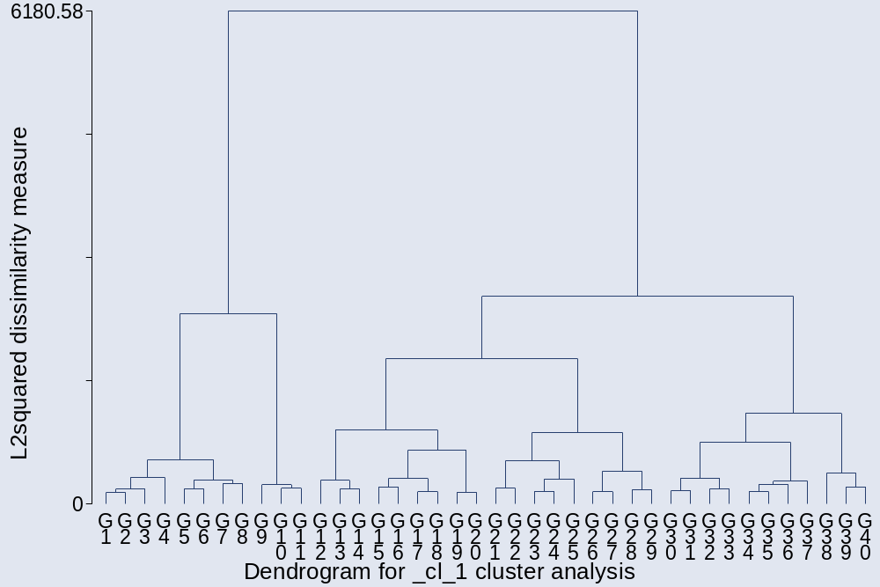

. cluster stop
+---------------------------+
| | Calinski/ |
| Number of | Harabasz |
| clusters | pseudo-F |
|-------------+-------------|
| 2 | 151.37 |
| 3 | 115.33 |
| 4 | 104.77 |
| 5 | 96.67 |
| 6 | 87.22 |
| 7 | 79.85 |
| 8 | 74.75 |
| 9 | 70.44 |
| 10 | 66.71 |
| 11 | 63.19 |
| 12 | 60.38 |
| 13 | 57.46 |
| 14 | 54.93 |
| 15 | 52.52 |
+---------------------------+

. cluster stop, rule (duda)
+-----------------------------------------+
| | Duda/Hart |
| Number of | | pseudo |
| clusters | Je(2)/Je(1) | T-squared |
|-------------+-------------+-------------|
| 1 | 0.8590 | 151.37 |
| 2 | 0.9117 | 77.70 |
| 3 | 0.7110 | 47.97 |
| 4 | 0.8915 | 53.69 |
| 5 | 0.8870 | 45.75 |
| 6 | 0.8909 | 33.55 |
| 7 | 0.8617 | 26.48 |
| 8 | 0.8754 | 35.00 |
| 9 | 0.8703 | 28.02 |
| 10 | 0.8752 | 11.41 |
| 11 | 0.8477 | 14.02 |
| 12 | 0.7950 | 21.92 |
| 13 | 0.8573 | 18.48 |
| 14 | 0.8315 | 7.50 |
| 15 | 0.8864 | 15.25 |
+-----------------------------------------+

The dendrogram and the stopping rules suggest between 2 to 4 groups:

. cluster gen gward2=group (2)
. cluster gen gward3=group (3)
. cluster gen gward4=group (4)

Two groups:

. bysort gward2: sum nu*
_______________________________________________________________________________
-> gward2 = 1

Variable | Obs Mean Std. Dev. Min Max
-------------+--------------------------------------------------------
nutariff | 120 3.916667 1.375557 1 5
numinw | 120 3.216667 1.518421 1 5
nuOSHA | 120 2.6 1.279443 1 5
nuFDA | 120 2.641667 1.448243 1 5
nuEPA | 120 2.533333 1.289475 1 5
-------------+--------------------------------------------------------
nudisc | 120 2.741667 1.509053 1 5
nudrugs | 120 2.416667 1.558837 1 5
nuprost | 120 3.075 1.450369 1 5
nugambl | 120 2.933333 1.596916 1 5
nuguns | 120 3.283333 1.604528 1 5
-------------+--------------------------------------------------------
nugovown | 120 4.441667 .9419793 1 5
nuredist | 120 3.541667 1.24951 1 5
nuschool | 120 3.425 1.412207 1 5
numonet | 120 2.491667 1.209179 1 5
nufisc | 120 3.058333 1.32396 1 5
-------------+--------------------------------------------------------
nuimmi | 120 2.633333 1.466336 1 5
numilaid | 120 2.766667 1.294678 1 5
nuWB | 120 2.883333 1.271427 1 5

_______________________________________________________________________________
-> gward2 = 2

Variable | Obs Mean Std. Dev. Min Max
-------------+--------------------------------------------------------
nutariff | 804 3.570896 1.173047 1 5
numinw | 804 1.340796 .8051994 1 5
nuOSHA | 804 1.180348 .4925971 1 4
nuFDA | 804 1.258706 .5907011 1 5
nuEPA | 804 1.095771 .3188273 1 3
-------------+--------------------------------------------------------
nudisc | 804 1.190299 .5533599 1 5
nudrugs | 804 2.368159 1.32277 1 5
nuprost | 804 3.128109 1.219295 1 5
nugambl | 804 2.787313 1.26876 1 5
nuguns | 804 1.370647 .8466087 1 5
-------------+--------------------------------------------------------
nugovown | 804 3.179104 1.298629 1 5
nuredist | 804 1.33209 .675429 1 5
nuschool | 804 1.431592 .8330334 1 5
numonet | 804 1.983831 .9194114 1 5
nufisc | 804 1.951493 .93972 1 5
-------------+--------------------------------------------------------
nuimmi | 804 3.539801 1.341792 1 5
numilaid | 804 3.424129 1.367826 1 5
nuWB | 804 2.05597 1.218619 1 5

Those with missing values:
_______________________________________________________________________________
-> gward2 = .

Variable | Obs Mean Std. Dev. Min Max
-------------+--------------------------------------------------------
nutariff | 268 3.526119 1.142992 1 5
numinw | 281 1.24911 .6880674 1 5
nuOSHA | 280 1.192857 .5273377 1 4
nuFDA | 276 1.300725 .7033423 1 5
nuEPA | 279 1.111111 .4048072 1 4
-------------+--------------------------------------------------------
nudisc | 281 1.288256 .7737923 1 5
nudrugs | 272 2.360294 1.334597 1 5
nuprost | 257 3.124514 1.218374 1 5
nugambl | 243 2.580247 1.238476 1 5
nuguns | 276 1.387681 .9371487 1 5
-------------+--------------------------------------------------------
nugovown | 249 3.305221 1.219471 1 5
nuredist | 253 1.403162 .7839599 1 5
nuschool | 166 1.644578 1.201086 1 5
numonet | 206 2.082524 .9149093 1 5
nufisc | 206 2.024272 .9445057 1 5
-------------+--------------------------------------------------------
nuimmi | 280 3.517857 1.362465 1 5
numilaid | 264 3.450758 1.391664 1 5
nuWB | 274 2.080292 1.155071 1 5

The two groups looks like broadly left and right groups.

Three groups:

. bysort gward3: sum nu*
_______________________________________________________________________________
-> gward3 = 1

Variable | Obs Mean Std. Dev. Min Max
-------------+--------------------------------------------------------
nutariff | 120 3.916667 1.375557 1 5
numinw | 120 3.216667 1.518421 1 5
nuOSHA | 120 2.6 1.279443 1 5
nuFDA | 120 2.641667 1.448243 1 5
nuEPA | 120 2.533333 1.289475 1 5
-------------+--------------------------------------------------------
nudisc | 120 2.741667 1.509053 1 5
nudrugs | 120 2.416667 1.558837 1 5
nuprost | 120 3.075 1.450369 1 5
nugambl | 120 2.933333 1.596916 1 5
nuguns | 120 3.283333 1.604528 1 5
-------------+--------------------------------------------------------
nugovown | 120 4.441667 .9419793 1 5
nuredist | 120 3.541667 1.24951 1 5
nuschool | 120 3.425 1.412207 1 5
numonet | 120 2.491667 1.209179 1 5
nufisc | 120 3.058333 1.32396 1 5
-------------+--------------------------------------------------------
nuimmi | 120 2.633333 1.466336 1 5
numilaid | 120 2.766667 1.294678 1 5

nuWB | 120 2.883333 1.271427 1 5

_______________________________________________________________________________
-> gward3 = 2

Variable | Obs Mean Std. Dev. Min Max
-------------+--------------------------------------------------------
nutariff | 443 3.573363 1.194222 1 5
numinw | 443 1.363431 .8980718 1 5
nuOSHA | 443 1.207675 .5358081 1 4
nuFDA | 443 1.352144 .6910309 1 5
nuEPA | 443 1.130926 .357234 1 3
-------------+--------------------------------------------------------
nudisc | 443 1.209932 .5930905 1 5
nudrugs | 443 2.79684 1.365141 1 5
nuprost | 443 3.598194 1.147965 1 5
nugambl | 443 3.261851 1.241829 1 5
nuguns | 443 1.413093 .8941793 1 5
-------------+--------------------------------------------------------
nugovown | 443 3.029345 1.30663 1 5
nuredist | 443 1.361174 .7122271 1 5
nuschool | 443 1.512415 .9182436 1 5
numonet | 443 2.293454 .9605935 1 5
nufisc | 443 2.230248 .9846269 1 5
-------------+--------------------------------------------------------
nuimmi | 443 3.68623 1.305562 1 5
numilaid | 443 3.941309 1.242602 1 5
nuWB | 443 2.480813 1.328922 1 5

_______________________________________________________________________________
-> gward3 = 3

Variable | Obs Mean Std. Dev. Min Max
-------------+--------------------------------------------------------
nutariff | 361 3.567867 1.148172 1 5
numinw | 361 1.313019 .6741843 1 4
nuOSHA | 361 1.146814 .4321099 1 4
nuFDA | 361 1.144044 .4099786 1 3
nuEPA | 361 1.052632 .2581989 1 3
-------------+--------------------------------------------------------
nudisc | 361 1.166205 .5000769 1 5
nudrugs | 361 1.842105 1.054093 1 5
nuprost | 361 2.551247 1.04523 1 5
nugambl | 361 2.204986 1.039272 1 5
nuguns | 361 1.31856 .7823853 1 5
-------------+--------------------------------------------------------
nugovown | 361 3.362881 1.266516 1 5
nuredist | 361 1.296399 .6264657 1 5
nuschool | 361 1.33241 .7033863 1 5
numonet | 361 1.603878 .6999099 1 5
nufisc | 361 1.609418 .7526398 1 5
-------------+--------------------------------------------------------
nuimmi | 361 3.360111 1.365432 1 5
numilaid | 361 2.789474 1.242757 1 5
nuWB | 361 1.534626 .8059108 1 5

Those with missing values:
_______________________________________________________________________________
-> gward3 = .

Variable | Obs Mean Std. Dev. Min Max
-------------+--------------------------------------------------------
nutariff | 268 3.526119 1.142992 1 5
numinw | 281 1.24911 .6880674 1 5
nuOSHA | 280 1.192857 .5273377 1 4
nuFDA | 276 1.300725 .7033423 1 5
nuEPA | 279 1.111111 .4048072 1 4
-------------+--------------------------------------------------------
nudisc | 281 1.288256 .7737923 1 5
nudrugs | 272 2.360294 1.334597 1 5
nuprost | 257 3.124514 1.218374 1 5
nugambl | 243 2.580247 1.238476 1 5
nuguns | 276 1.387681 .9371487 1 5
-------------+--------------------------------------------------------
nugovown | 249 3.305221 1.219471 1 5
nuredist | 253 1.403162 .7839599 1 5
nuschool | 166 1.644578 1.201086 1 5
numonet | 206 2.082524 .9149093 1 5
nufisc | 206 2.024272 .9445057 1 5
-------------+--------------------------------------------------------
nuimmi | 280 3.517857 1.362465 1 5
numilaid | 264 3.450758 1.391664 1 5
nuWB | 274 2.080292 1.155071 1 5

Four groups:

. bysort gward4: sum nu*
_______________________________________________________________________________
-> gward4 = 1

Variable | Obs Mean Std. Dev. Min Max
-------------+--------------------------------------------------------
nutariff | 82 3.5 1.416394 1 5
numinw | 82 2.609756 1.429462 1 5
nuOSHA | 82 2 .9558139 1 5
nuFDA | 82 1.939024 1.092596 1 5
nuEPA | 82 2.012195 1.059861 1 5
-------------+--------------------------------------------------------
nudisc | 82 2.463415 1.450373 1 5
nudrugs | 82 1.621951 1.061565 1 5
nuprost | 82 2.390244 1.194184 1 5
nugambl | 82 2.134146 1.234906 1 5
nuguns | 82 2.743902 1.538084 1 5
-------------+--------------------------------------------------------
nugovown | 82 4.219512 1.054378 1 5
nuredist | 82 3.341463 1.239469 1 5
nuschool | 82 3.195122 1.426721 1 5
numonet | 82 2.207317 1.027256 1 5
nufisc | 82 2.560976 1.155743 1 5
-------------+--------------------------------------------------------
nuimmi | 82 2.256098 1.27474 1 5
numilaid | 82 2.646341 1.230998 1 5
nuWB | 82 2.439024 1.112195 1 5

A libertarian group:
_____________________________________________________________________________
-> gward4 = 2

Variable | Obs Mean Std. Dev. Min Max
-------------+--------------------------------------------------------
nutariff | 38 4.815789 .6918547 1 5
numinw | 38 4.526316 .6034514 3 5
nuOSHA | 38 3.894737 .8633522 2 5
nuFDA | 38 4.157895 .8228597 3 5
nuEPA | 38 3.657895 .9939361 2 5
-------------+--------------------------------------------------------
nudisc | 38 3.342105 1.475499 1 5
nudrugs | 38 4.131579 .9634132 2 5
nuprost | 38 4.552632 .6016809 3 5
nugambl | 38 4.657895 .6271478 3 5
nuguns | 38 4.447368 1.031854 1 5
-------------+--------------------------------------------------------
nugovown | 38 4.921053 .2732763 4 5
nuredist | 38 3.973684 1.173741 1 5
nuschool | 38 3.921053 1.260235 1 5
numonet | 38 3.105263 1.351465 1 5
nufisc | 38 4.131579 .9910697 2 5
-------------+--------------------------------------------------------
nuimmi | 38 3.447368 1.536886 1 5
numilaid | 38 3.026316 1.404372 1 5
nuWB | 38 3.842105 1.053343 2 5

_______________________________________________________________________________
-> gward4 = 3

Variable | Obs Mean Std. Dev. Min Max
-------------+--------------------------------------------------------
nutariff | 443 3.573363 1.194222 1 5
numinw | 443 1.363431 .8980718 1 5
nuOSHA | 443 1.207675 .5358081 1 4
nuFDA | 443 1.352144 .6910309 1 5
nuEPA | 443 1.130926 .357234 1 3
-------------+--------------------------------------------------------
nudisc | 443 1.209932 .5930905 1 5
nudrugs | 443 2.79684 1.365141 1 5
nuprost | 443 3.598194 1.147965 1 5
nugambl | 443 3.261851 1.241829 1 5
nuguns | 443 1.413093 .8941793 1 5
-------------+--------------------------------------------------------
nugovown | 443 3.029345 1.30663 1 5
nuredist | 443 1.361174 .7122271 1 5
nuschool | 443 1.512415 .9182436 1 5
numonet | 443 2.293454 .9605935 1 5
nufisc | 443 2.230248 .9846269 1 5
-------------+--------------------------------------------------------
nuimmi | 443 3.68623 1.305562 1 5
numilaid | 443 3.941309 1.242602 1 5
nuWB | 443 2.480813 1.328922 1 5

_______________________________________________________________________________
-> gward4 = 4

Variable | Obs Mean Std. Dev. Min Max
-------------+--------------------------------------------------------
nutariff | 361 3.567867 1.148172 1 5
numinw | 361 1.313019 .6741843 1 4
nuOSHA | 361 1.146814 .4321099 1 4
nuFDA | 361 1.144044 .4099786 1 3
nuEPA | 361 1.052632 .2581989 1 3
-------------+--------------------------------------------------------
nudisc | 361 1.166205 .5000769 1 5
nudrugs | 361 1.842105 1.054093 1 5
nuprost | 361 2.551247 1.04523 1 5
nugambl | 361 2.204986 1.039272 1 5
nuguns | 361 1.31856 .7823853 1 5
-------------+--------------------------------------------------------
nugovown | 361 3.362881 1.266516 1 5
nuredist | 361 1.296399 .6264657 1 5
nuschool | 361 1.33241 .7033863 1 5
numonet | 361 1.603878 .6999099 1 5
nufisc | 361 1.609418 .7526398 1 5
-------------+--------------------------------------------------------
nuimmi | 361 3.360111 1.365432 1 5
numilaid | 361 2.789474 1.242757 1 5
nuWB | 361 1.534626 .8059108 1 5

Those with missing values:
_______________________________________________________________________________
-> gward4 = .

Variable | Obs Mean Std. Dev. Min Max
-------------+--------------------------------------------------------
nutariff | 268 3.526119 1.142992 1 5
numinw | 281 1.24911 .6880674 1 5
nuOSHA | 280 1.192857 .5273377 1 4
nuFDA | 276 1.300725 .7033423 1 5
nuEPA | 279 1.111111 .4048072 1 4
-------------+--------------------------------------------------------
nudisc | 281 1.288256 .7737923 1 5
nudrugs | 272 2.360294 1.334597 1 5
nuprost | 257 3.124514 1.218374 1 5
nugambl | 243 2.580247 1.238476 1 5
nuguns | 276 1.387681 .9371487 1 5
-------------+--------------------------------------------------------
nugovown | 249 3.305221 1.219471 1 5
nuredist | 253 1.403162 .7839599 1 5
nuschool | 166 1.644578 1.201086 1 5
numonet | 206 2.082524 .9149093 1 5
nufisc | 206 2.024272 .9445057 1 5
-------------+--------------------------------------------------------
nuimmi | 280 3.517857 1.362465 1 5
numilaid | 264 3.450758 1.391664 1 5
nuWB | 274 2.080292 1.155071 1 5

I go on to drop public school, fiscal and monetary policy and redo the clustering using again the Wards Linkage method:

. drop nuschool nufisc numonet
. cluster wardslinkage nu*
cluster name: _cl_2

. cluster tree, vertlab cutnumber (40)
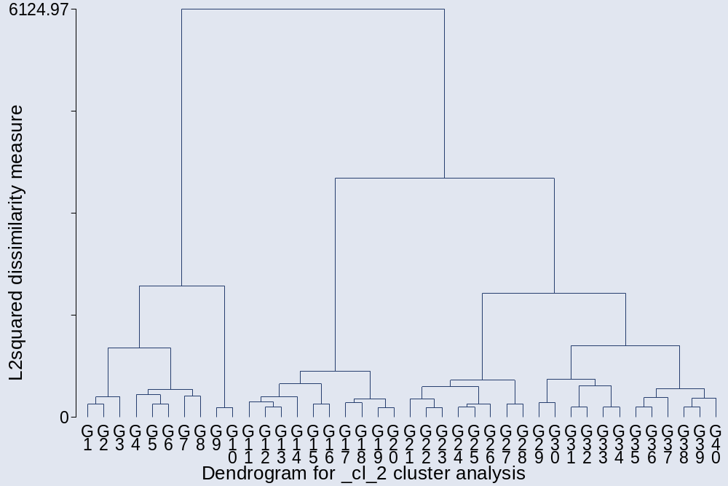

. cluster stop

+---------------------------+
| | Calinski/ |
| Number of | Harabasz |
| clusters | pseudo-F |
|-------------+-------------|
| 2 | 181.62 |
| 3 | 159.97 |
| 4 | 136.41 |
| 5 | 126.28 |
| 6 | 113.30 |
| 7 | 105.07 |
| 8 | 96.51 |
| 9 | 89.32 |
| 10 | 83.76 |
| 11 | 79.09 |
| 12 | 75.23 |
| 13 | 72.02 |
| 14 | 69.23 |
| 15 | 66.85 |
+---------------------------+

. cluster stop, rule(duda)

+-----------------------------------------+
| | Duda/Hart |
| Number of | | pseudo |
| clusters | Je(2)/Je(1) | T-squared |
|-------------+-------------+-------------|
| 1 | 0.8531 | 181.62 |
| 2 | 0.8657 | 137.13 |
| 3 | 0.7791 | 47.92 |
| 4 | 0.8823 | 78.94 |
| 5 | 0.8782 | 44.81 |
| 6 | 0.8278 | 28.09 |
| 7 | 0.9059 | 30.13 |
| 8 | 0.8746 | 29.39 |
| 9 | 0.8917 | 32.42 |
| 10 | 0.8839 | 23.38 |
| 11 | 0.8162 | 27.46 |
| 12 | 0.8656 | 29.96 |
| 13 | 0.8666 | 17.86 |
| 14 | 0.8710 | 11.56 |
| 15 | 0.7984 | 11.36 |
+-----------------------------------------+

The dendrogram and the stopping rules suggest 4-6 groups:

. cluster gen gward24=group (4)
. cluster gen gward25=group (5)
. cluster gen gward26=group (6)

Four groups:

. bysort gward24: sum nu*
_______________________________________________________________________________
-> gward24 = 1

Variable | Obs Mean Std. Dev. Min Max
-------------+--------------------------------------------------------
nutariff | 137 4.145985 1.153895 1 5
numinw | 137 3.124088 1.274439 1 5
nuOSHA | 137 2.153285 .8984506 1 5
nuFDA | 137 1.948905 1.002359 1 5
nuEPA | 137 1.919708 .9553133 1 5
-------------+--------------------------------------------------------
nudisc | 137 2.19708 1.397684 1 5
nudrugs | 137 2.19708 1.30519 1 5
nuprost | 137 3.167883 1.309296 1 5
nugambl | 137 3.080292 1.361543 1 5
nuguns | 137 2.467153 1.510021 1 5
-------------+--------------------------------------------------------
nugovown | 137 4.372263 .8994058 2 5
nuredist | 137 2.693431 1.35886 1 5
nuimmi | 137 2.854015 1.385535 1 5
numilaid | 137 2.467153 1.176055 1 5
nuWB | 137 2.189781 1.025648 1 5

A libertarian group:
_______________________________________________________________________________
-> gward24 = 2

Variable | Obs Mean Std. Dev. Min Max
-------------+--------------------------------------------------------
nutariff | 34 4.823529 .7164977 1 5
numinw | 34 4.647059 .4850713 4 5
nuOSHA | 34 4.029412 .7581994 3 5
nuFDA | 34 4.235294 .8186768 3 5
nuEPA | 34 3.735294 .9312365 2 5
-------------+--------------------------------------------------------
nudisc | 34 3.470588 1.353677 1 5
nudrugs | 34 4.264706 .8637067 2 5
nuprost | 34 4.647059 .4850713 4 5
nugambl | 34 4.735294 .5110194 3 5
nuguns | 34 4.5 .9293204 1 5
-------------+--------------------------------------------------------
nugovown | 34 4.941176 .2388326 4 5
nuredist | 34 4.117647 1.066422 2 5
nuimmi | 34 3.5 1.561856 1 5
numilaid | 34 3.147059 1.305753 1 5
nuWB | 34 3.911765 1.055079 2 5

_______________________________________________________________________________
-> gward24 = 3

Variable | Obs Mean Std. Dev. Min Max
-------------+--------------------------------------------------------
nutariff | 292 3.280822 1.216966 1 5
numinw | 292 1.256849 .6140852 1 4
nuOSHA | 292 1.174658 .48373 1 4
nuFDA | 292 1.205479 .5166347 1 4
nuEPA | 292 1.109589 .3541271 1 3
-------------+--------------------------------------------------------
nudisc | 292 1.263699 .5998144 1 5
nudrugs | 292 1.465753 .8178791 1 4
nuprost | 292 2.226027 .9828114 1 5
nugambl | 292 2.071918 1.024594 1 5
nuguns | 292 1.520548 .9358766 1 5
-------------+--------------------------------------------------------
nugovown | 292 3.640411 1.194551 1 5
nuredist | 292 1.609589 .8919132 1 5
nuimmi | 292 2.441781 1.215606 1 5
numilaid | 292 2.684932 1.236631 1 5
nuWB | 292 1.777397 .9888221 1 5

_______________________________________________________________________________
-> gward24 = 4

Variable | Obs Mean Std. Dev. Min Max
-------------+--------------------------------------------------------
nutariff | 594 3.580808 1.126577 1 5
numinw | 594 1.127946 .4312343 1 5
nuOSHA | 594 1.079125 .288279 1 3
nuFDA | 594 1.23569 .602137 1 5
nuEPA | 594 1.031987 .1761125 1 2
-------------+--------------------------------------------------------
nudisc | 594 1.126263 .4745288 1 5
nudrugs | 594 2.73569 1.320166 1 5
nuprost | 594 3.452862 1.107372 1 5
nugambl | 594 2.929293 1.244909 1 5
nuguns | 594 1.245791 .725487 1 5
-------------+--------------------------------------------------------
nugovown | 594 2.87037 1.227165 1 5
nuredist | 594 1.173401 .4738343 1 4
nuimmi | 594 4.063973 1.072081 1 5
numilaid | 594 3.900673 1.228621 1 5
nuWB | 594 2.222222 1.309369 1 5

Those with missing values:
_______________________________________________________________________________
-> gward24 = .

Variable | Obs Mean Std. Dev. Min Max
-------------+--------------------------------------------------------
nutariff | 135 3.474074 1.183403 1 5
numinw | 148 1.297297 .6747079 1 5
nuOSHA | 147 1.217687 .5912259 1 4
nuFDA | 143 1.335664 .7310426 1 5
nuEPA | 146 1.150685 .4747771 1 4
-------------+--------------------------------------------------------
nudisc | 148 1.290541 .7846606 1 5
nudrugs | 139 2.42446 1.340443 1 5
nuprost | 124 3.177419 1.262649 1 5
nugambl | 110 2.654545 1.323301 1 5
nuguns | 143 1.426573 1.003441 1 5
-------------+--------------------------------------------------------
nugovown | 116 3.25 1.264051 1 5
nuredist | 120 1.458333 .8391255 1 5
nuimmi | 147 3.469388 1.396209 1 5
numilaid | 131 3.435115 1.403837 1 5
nuWB | 141 2.106383 1.169262 1 5

Five groups:

. bysort gward25: sum nu*
_______________________________________________________________________________
-> gward25 = 1

Variable | Obs Mean Std. Dev. Min Max
-------------+--------------------------------------------------------
nutariff | 137 4.145985 1.153895 1 5
numinw | 137 3.124088 1.274439 1 5
nuOSHA | 137 2.153285 .8984506 1 5
nuFDA | 137 1.948905 1.002359 1 5
nuEPA | 137 1.919708 .9553133 1 5
-------------+--------------------------------------------------------
nudisc | 137 2.19708 1.397684 1 5
nudrugs | 137 2.19708 1.30519 1 5
nuprost | 137 3.167883 1.309296 1 5
nugambl | 137 3.080292 1.361543 1 5
nuguns | 137 2.467153 1.510021 1 5
-------------+--------------------------------------------------------
nugovown | 137 4.372263 .8994058 2 5
nuredist | 137 2.693431 1.35886 1 5
nuimmi | 137 2.854015 1.385535 1 5
numilaid | 137 2.467153 1.176055 1 5
nuWB | 137 2.189781 1.025648 1 5

The libertarian group:
_______________________________________________________________________________
-> gward25 = 2

Variable | Obs Mean Std. Dev. Min Max
-------------+--------------------------------------------------------
nutariff | 34 4.823529 .7164977 1 5
numinw | 34 4.647059 .4850713 4 5
nuOSHA | 34 4.029412 .7581994 3 5
nuFDA | 34 4.235294 .8186768 3 5
nuEPA | 34 3.735294 .9312365 2 5
-------------+--------------------------------------------------------
nudisc | 34 3.470588 1.353677 1 5
nudrugs | 34 4.264706 .8637067 2 5
nuprost | 34 4.647059 .4850713 4 5
nugambl | 34 4.735294 .5110194 3 5
nuguns | 34 4.5 .9293204 1 5
-------------+--------------------------------------------------------
nugovown | 34 4.941176 .2388326 4 5
nuredist | 34 4.117647 1.066422 2 5
nuimmi | 34 3.5 1.561856 1 5
numilaid | 34 3.147059 1.305753 1 5
nuWB | 34 3.911765 1.055079 2 5

_______________________________________________________________________________
-> gward25 = 3

Variable | Obs Mean Std. Dev. Min Max
-------------+--------------------------------------------------------
nutariff | 292 3.280822 1.216966 1 5
numinw | 292 1.256849 .6140852 1 4
nuOSHA | 292 1.174658 .48373 1 4
nuFDA | 292 1.205479 .5166347 1 4
nuEPA | 292 1.109589 .3541271 1 3
-------------+--------------------------------------------------------
nudisc | 292 1.263699 .5998144 1 5
nudrugs | 292 1.465753 .8178791 1 4
nuprost | 292 2.226027 .9828114 1 5
nugambl | 292 2.071918 1.024594 1 5
nuguns | 292 1.520548 .9358766 1 5
-------------+--------------------------------------------------------
nugovown | 292 3.640411 1.194551 1 5
nuredist | 292 1.609589 .8919132 1 5
nuimmi | 292 2.441781 1.215606 1 5
numilaid | 292 2.684932 1.236631 1 5
nuWB | 292 1.777397 .9888221 1 5

_______________________________________________________________________________
-> gward25 = 4

Variable | Obs Mean Std. Dev. Min Max
-------------+--------------------------------------------------------
nutariff | 269 3.996283 .9830585 1 5
numinw | 269 1.141264 .4431568 1 5
nuOSHA | 269 1.100372 .3248993 1 3
nuFDA | 269 1.137546 .3859026 1 4
nuEPA | 269 1.026022 .1594983 1 2
-------------+--------------------------------------------------------
nudisc | 269 1.107807 .3555194 1 3
nudrugs | 269 2.104089 1.114835 1 5
nuprost | 269 3.066914 1.087232 1 5
nugambl | 269 2.501859 1.16101 1 5
nuguns | 269 1.096654 .3427663 1 3
-------------+--------------------------------------------------------
nugovown | 269 3.211896 1.131176 1 5
nuredist | 269 1.133829 .3724774 1 3
nuimmi | 269 4.312268 .7623841 2 5
numilaid | 269 3.665428 1.251698 1 5
nuWB | 269 1.375465 .6721487 1 4

_______________________________________________________________________________
-> gward25 = 5

Variable | Obs Mean Std. Dev. Min Max
-------------+--------------------------------------------------------
nutariff | 325 3.236923 1.123208 1 5
numinw | 325 1.116923 .4214793 1 4
nuOSHA | 325 1.061538 .2531848 1 3
nuFDA | 325 1.316923 .7251158 1 5
nuEPA | 325 1.036923 .1888637 1 2
-------------+--------------------------------------------------------
nudisc | 325 1.141538 .5541349 1 5
nudrugs | 325 3.258462 1.247577 1 5
nuprost | 325 3.772308 1.020093 1 5
nugambl | 325 3.283077 1.201795 1 5
nuguns | 325 1.369231 .9123506 1 5
-------------+--------------------------------------------------------
nugovown | 325 2.587692 1.233222 1 5

nuredist | 325 1.206154 .5420232 1 4
nuimmi | 325 3.858462 1.236644 1 5
numilaid | 325 4.095385 1.175946 1 5
nuWB | 325 2.923077 1.294667 1 5
Those with missing values:
_______________________________________________________________________________
-> gward25 = .

Variable | Obs Mean Std. Dev. Min Max
-------------+--------------------------------------------------------
nutariff | 135 3.474074 1.183403 1 5
numinw | 148 1.297297 .6747079 1 5
nuOSHA | 147 1.217687 .5912259 1 4
nuFDA | 143 1.335664 .7310426 1 5
nuEPA | 146 1.150685 .4747771 1 4
-------------+--------------------------------------------------------
nudisc | 148 1.290541 .7846606 1 5
nudrugs | 139 2.42446 1.340443 1 5
nuprost | 124 3.177419 1.262649 1 5
nugambl | 110 2.654545 1.323301 1 5
nuguns | 143 1.426573 1.003441 1 5
-------------+--------------------------------------------------------
nugovown | 116 3.25 1.264051 1 5
nuredist | 120 1.458333 .8391255 1 5
nuimmi | 147 3.469388 1.396209 1 5
numilaid | 131 3.435115 1.403837 1 5
nuWB | 141 2.106383 1.169262 1 5

Six groups:

. bysort gward26: sum nu*
______________________________________________________________________________
-> gward26 = 1

Variable | Obs Mean Std. Dev. Min Max
-------------+--------------------------------------------------------
nutariff | 137 4.145985 1.153895 1 5
numinw | 137 3.124088 1.274439 1 5
nuOSHA | 137 2.153285 .8984506 1 5
nuFDA | 137 1.948905 1.002359 1 5
nuEPA | 137 1.919708 .9553133 1 5
-------------+--------------------------------------------------------
nudisc | 137 2.19708 1.397684 1 5
nudrugs | 137 2.19708 1.30519 1 5
nuprost | 137 3.167883 1.309296 1 5
nugambl | 137 3.080292 1.361543 1 5
nuguns | 137 2.467153 1.510021 1 5
-------------+--------------------------------------------------------
nugovown | 137 4.372263 .8994058 2 5
nuredist | 137 2.693431 1.35886 1 5
nuimmi | 137 2.854015 1.385535 1 5
numilaid | 137 2.467153 1.176055 1 5
nuWB | 137 2.189781 1.025648 1 5

The libertarian group:
_______________________________________________________________________________
-> gward26 = 2

Variable | Obs Mean Std. Dev. Min Max
-------------+--------------------------------------------------------
nutariff | 34 4.823529 .7164977 1 5
numinw | 34 4.647059 .4850713 4 5
nuOSHA | 34 4.029412 .7581994 3 5
nuFDA | 34 4.235294 .8186768 3 5
nuEPA | 34 3.735294 .9312365 2 5
-------------+--------------------------------------------------------
nudisc | 34 3.470588 1.353677 1 5
nudrugs | 34 4.264706 .8637067 2 5
nuprost | 34 4.647059 .4850713 4 5
nugambl | 34 4.735294 .5110194 3 5
nuguns | 34 4.5 .9293204 1 5
-------------+--------------------------------------------------------
nugovown | 34 4.941176 .2388326 4 5
nuredist | 34 4.117647 1.066422 2 5
nuimmi | 34 3.5 1.561856 1 5
numilaid | 34 3.147059 1.305753 1 5
nuWB | 34 3.911765 1.055079 2 5

_______________________________________________________________________________
-> gward26 = 3

Variable | Obs Mean Std. Dev. Min Max
-------------+--------------------------------------------------------
nutariff | 292 3.280822 1.216966 1 5
numinw | 292 1.256849 .6140852 1 4
nuOSHA | 292 1.174658 .48373 1 4
nuFDA | 292 1.205479 .5166347 1 4
nuEPA | 292 1.109589 .3541271 1 3
-------------+--------------------------------------------------------
nudisc | 292 1.263699 .5998144 1 5
nudrugs | 292 1.465753 .8178791 1 4
nuprost | 292 2.226027 .9828114 1 5
nugambl | 292 2.071918 1.024594 1 5
nuguns | 292 1.520548 .9358766 1 5
-------------+--------------------------------------------------------
nugovown | 292 3.640411 1.194551 1 5
nuredist | 292 1.609589 .8919132 1 5
nuimmi | 292 2.441781 1.215606 1 5
numilaid | 292 2.684932 1.236631 1 5
nuWB | 292 1.777397 .9888221 1 5

_______________________________________________________________________________
-> gward26 = 4

Variable | Obs Mean Std. Dev. Min Max
-------------+--------------------------------------------------------
nutariff | 269 3.996283 .9830585 1 5
numinw | 269 1.141264 .4431568 1 5
nuOSHA | 269 1.100372 .3248993 1 3

nuFDA | 269 1.137546 .3859026 1 4
nuEPA | 269 1.026022 .1594983 1 2
-------------+--------------------------------------------------------
nudisc | 269 1.107807 .3555194 1 3
nudrugs | 269 2.104089 1.114835 1 5
nuprost | 269 3.066914 1.087232 1 5
nugambl | 269 2.501859 1.16101 1 5
nuguns | 269 1.096654 .3427663 1 3
-------------+--------------------------------------------------------
nugovown | 269 3.211896 1.131176 1 5
nuredist | 269 1.133829 .3724774 1 3
nuimmi | 269 4.312268 .7623841 2 5
numilaid | 269 3.665428 1.251698 1 5
nuWB | 269 1.375465 .6721487 1 4

_______________________________________________________________________________
-> gward26 = 5

Variable | Obs Mean Std. Dev. Min Max
-------------+--------------------------------------------------------
nutariff | 207 3.207729 1.110558 1 5
numinw | 207 1.086957 .3149571 1 3
nuOSHA | 207 1.05314 .2248566 1 2
nuFDA | 207 1.333333 .7882634 1 5
nuEPA | 207 1.038647 .1932203 1 2
-------------+--------------------------------------------------------
nudisc | 207 1.067633 .3345272 1 4
nudrugs | 207 2.855072 1.206077 1 5
nuprost | 207 3.415459 .9559993 1 5
nugambl | 207 2.869565 1.091624 1 5
nuguns | 207 1.231884 .6418631 1 5
-------------+--------------------------------------------------------
nugovown | 207 2.676329 1.233265 1 5
nuredist | 207 1.21256 .533569 1 3
nuimmi | 207 4.072464 1.11022 1 5
numilaid | 207 4.444444 .8733128 1 5
nuWB | 207 3.454106 1.059662 1 5

_______________________________________________________________________________

-> gward26 = 6

Variable | Obs Mean Std. Dev. Min Max
-------------+--------------------------------------------------------
nutariff | 118 3.288136 1.148032 1 5
numinw | 118 1.169492 .5593813 1 4
nuOSHA | 118 1.076271 .2969008 1 3
nuFDA | 118 1.288136 .6005937 1 3
nuEPA | 118 1.033898 .1817391 1 2
-------------+--------------------------------------------------------
nudisc | 118 1.271186 .7916338 1 5
nudrugs | 118 3.966102 .9778068 1 5
nuprost | 118 4.398305 .8074422 1 5
nugambl | 118 4.008475 1.033588 1 5
nuguns | 118 1.610169 1.219737 1 5
-------------+--------------------------------------------------------
nugovown | 118 2.432203 1.222851 1 5
nuredist | 118 1.194915 .5586687 1 4
nuimmi | 118 3.483051 1.357052 1 5
numilaid | 118 3.483051 1.375817 1 5
nuWB | 118 1.991525 1.136013 1 5

Those with missing values:
_______________________________________________________________________________
-> gward26 = .

Variable | Obs Mean Std. Dev. Min Max
-------------+--------------------------------------------------------
nutariff | 135 3.474074 1.183403 1 5
numinw | 148 1.297297 .6747079 1 5
nuOSHA | 147 1.217687 .5912259 1 4
nuFDA | 143 1.335664 .7310426 1 5
nuEPA | 146 1.150685 .4747771 1 4
-------------+--------------------------------------------------------
nudisc | 148 1.290541 .7846606 1 5
nudrugs | 139 2.42446 1.340443 1 5
nuprost | 124 3.177419 1.262649 1 5
nugambl | 110 2.654545 1.323301 1 5
nuguns | 143 1.426573 1.003441 1 5
-------------+--------------------------------------------------------
nugovown | 116 3.25 1.264051 1 5
nuredist | 120 1.458333 .8391255 1 5
nuimmi | 147 3.469388 1.396209 1 5
numilaid | 131 3.435115 1.403837 1 5
nuWB | 141 2.106383 1.169262 1 5

In what follows, the respondents who have recorded ”have no opinion” on policy items are merged with respondents who recorded “have mixed feelings” – both kinds of responses are coded 3 – interpreted as neutral responses. The purpose is to reduce the number of missing values on policy responses and see if increasing the N changes the overall patterns in the data.

The first analysis uses Complete Linkage clustering:

. cluster completelinkage cl*
cluster name: _cl_1

. cluster tree, vertlab cutnumber (45)
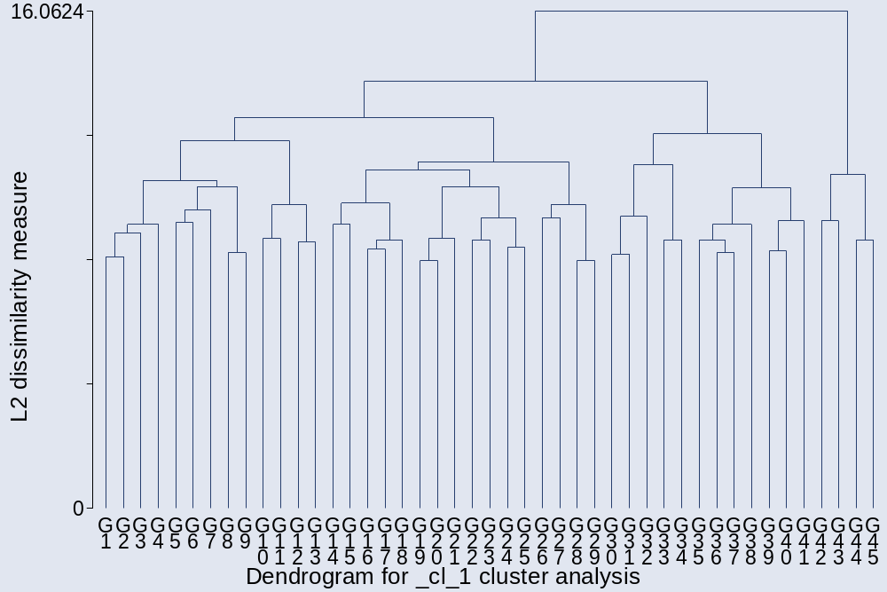

. cluster stop
+---------------------------+
| | Calinski/ |
| Number of | Harabasz |
| clusters | pseudo-F |
|-------------+-------------|
| 2 | 139.64 |
| 3 | 122.84 |
| 4 | 109.08 |
| 5 | 95.82 |
| 6 | 84.52 |
| 7 | 80.35 |
| 8 | 70.75 |
| 9 | 66.06 |
| 10 | 59.73 |
| 11 | 54.59 |
| 13 | 49.91 |
| 14 | 48.09 |
| 15 | 46.98 |
+---------------------------+

. cluster stop, rule (duda)

+-----------------------------------------+
| | Duda/Hart |
| Number of | | pseudo |
| clusters | Je(2)/Je(1) | T-squared |
|-------------+-------------+-------------|
| 1 | 0.8834 | 139.64 |
| 2 | 0.9161 | 93.78 |
| 3 | 0.9065 | 59.89 |
| 4 | 0.8905 | 54.25 |
| 5 | 0.8204 | 22.11 |
| 6 | 0.9217 | 40.63 |
| 7 | 0.9419 | 12.70 |
| 8 | 0.9453 | 22.62 |
| 9 | 0.8405 | 6.07 |
| 10 | 0.9423 | 4.22 |
| 13 | 0.9270 | 18.35 |
| 14 | 0.8723 | 20.21 |
+-----------------------------------------+

Seven groups:

. cluster gen gcom7 =group (7)

. bysort gcom7: sum cl*

_______________________________________________________________________________
-> gcom7 = 1

Variable | Obs Mean Std. Dev. Min Max
-------------+--------------------------------------------------------
cltariff | 71 3.802817 1.326862 1 5
clminw | 71 2.802817 1.337585 1 5
clOSHA | 71 2.140845 .8831077 1 4
clFDA | 71 1.985915 1.021105 1 5
clEPA | 71 2 .9411239 1 4
-------------+--------------------------------------------------------
cldisc | 71 2 1.253566 1 5
cldrugs | 71 1.464789 .8590857 1 5
clprost | 71 2.253521 1.051778 1 5
clgambl | 71 2.211268 1.229582 1 5
clguns | 71 2.985915 1.357445 1 5
-------------+--------------------------------------------------------
clgovown | 71 4.619718 .683817 3 5
clredist | 71 3.295775 1.187968 1 5
clschool | 71 3.028169 1.319868 1 5
clmonet | 71 2.056338 .9084889 1 4
clfisc | 71 2.394366 1.075425 1 5
-------------+--------------------------------------------------------
climmi | 71 2.197183 1.190675 1 5
clmilaid | 71 1.943662 .9693492 1 5
clWB | 71 2.309859 1.116008 1 5

_______________________________________________________________________________
-> gcom7 = 2

Variable | Obs Mean Std. Dev. Min Max
-------------+--------------------------------------------------------
cltariff | 32 4.8125 .4709291 3 5
clminw | 32 4.15625 .8466014 2 5
clOSHA | 32 2.15625 1.019468 1 4
clFDA | 32 2 1.135924 1 5
clEPA | 32 1.875 .9069623 1 5
-------------+--------------------------------------------------------
cldisc | 32 1.96875 1.177323 1 5
cldrugs | 32 3.34375 1.405275 1 5
clprost | 32 4.3125 .7378041 2 5
clgambl | 32 4.15625 .9196554 2 5
clguns | 32 2.40625 1.411002 1 5
-------------+--------------------------------------------------------
clgovown | 32 4.375 1.099853 1 5
clredist | 32 2.21875 1.184153 1 5
clschool | 32 2.09375 .9283831 1 4
clmonet | 32 2.21875 1.184153 1 5
clfisc | 32 3.3125 1.330474 1 5
-------------+--------------------------------------------------------
climmi | 32 3.9375 1.075759 1 5
clmilaid | 32 2.9375 1.216486 1 5
clWB | 32 1.9375 .8775883 1 4

_______________________________________________________________________________
-> gcom7 = 3

Variable | Obs Mean Std. Dev. Min Max
-------------+--------------------------------------------------------
cltariff | 393 3.178117 1.135615 1 5
clminw | 393 1.21374 .5487597 1 4
clOSHA | 393 1.150127 .423007 1 4
clFDA | 393 1.211196 .5380206 1 4
clEPA | 393 1.081425 .300486 1 3
-------------+--------------------------------------------------------
cldisc | 393 1.300254 .7467104 1 5
cldrugs | 393 1.73028 .9915583 1 5
clprost | 393 2.615776 1.157255 1 5
clgambl | 393 2.351145 1.160073 1 5
clguns | 393 1.328244 .7399953 1 5
-------------+--------------------------------------------------------
clgovown | 393 3.287532 1.182902 1 5
clredist | 393 1.585242 .8412127 1 5
clschool | 393 1.697201 1.079691 1 5
clmonet | 393 2.137405 .9617429 1 5
clfisc | 393 2.086514 .9021778 1 5
-------------+--------------------------------------------------------
climmi | 393 2.661578 1.295587 1 5
clmilaid | 393 3.114504 1.31693 1 5
clWB | 393 2.066158 1.11607 1 5

_______________________________________________________________________________
-> gcom7 = 4

Variable | Obs Mean Std. Dev. Min Max
-------------+--------------------------------------------------------
cltariff | 87 4.367816 .941485 1 5
clminw | 87 1.827586 1.002403 1 4
clOSHA | 87 1.471264 .7600349 1 3
clFDA | 87 1.597701 .8688374 1 4
clEPA | 87 1.264368 .5382955 1 3
-------------+--------------------------------------------------------
cldisc | 87 1.344828 .759859 1 5
cldrugs | 87 3 1.397672 1 5
clprost | 87 3.908046 1.018802 1 5
clgambl | 87 3.448276 1.217686 1 5
clguns | 87 1.655172 1.108399 1 5
-------------+--------------------------------------------------------
clgovown | 87 4.218391 .8548805 2 5
clredist | 87 1.471264 .6619049 1 4
clschool | 87 1.850575 1.262415 1 5
clmonet | 87 1.804598 .7445786 1 3
clfisc | 87 2.149425 .9587872 1 5
-------------+--------------------------------------------------------
climmi | 87 3.632184 1.267803 1 5
clmilaid | 87 2.287356 1.170451 1 5
clWB | 87 1.563218 .7880082 1 4

_______________________________________________________________________________
-> gcom7 = 5

Variable | Obs Mean Std. Dev. Min Max
-------------+--------------------------------------------------------
cltariff | 208 3.942308 1.015122 1 5
clminw | 208 1.197115 .5424861 1 4
clOSHA | 208 1.134615 .4183633 1 4
clFDA | 208 1.25 .5938493 1 5
clEPA | 208 1.048077 .2358993 1 3
-------------+--------------------------------------------------------
cldisc | 208 1.158654 .6207539 1 5
cldrugs | 208 1.942308 .9713472 1 5
clprost | 208 2.846154 1.038107 1 5
clgambl | 208 2.365385 1.017316 1 5
clguns | 208 1.182692 .5691662 1 5
-------------+--------------------------------------------------------
clgovown | 208 3.317308 1.135841 1 5
clredist | 208 1.149038 .5310631 1 5
clschool | 208 1.317308 .7647351 1 5
clmonet | 208 2.033654 .8975663 1 5
clfisc | 208 1.975962 .8760909 1 5
-------------+--------------------------------------------------------
climmi | 208 4.317308 .8137042 1 5
clmilaid | 208 4.163462 .998652 1 5
clWB | 208 1.860577 1.101068 1 5

_______________________________________________________________________________
-> gcom7 = 6

Variable | Obs Mean Std. Dev. Min Max
-------------+--------------------------------------------------------
cltariff | 235 3.276596 1.167621 1 5
clminw | 235 1.119149 .4269942 1 4
clOSHA | 235 1.059574 .2861919 1 4
clFDA | 235 1.212766 .5896606 1 5
clEPA | 235 1.059574 .3007537 1 4
-------------+--------------------------------------------------------
cldisc | 235 1.089362 .4088937 1 5
cldrugs | 235 3.497872 1.129914 1 5
clprost | 235 3.897872 .9188178 1 5
clgambl | 235 3.421277 1.164455 1 5
clguns | 235 1.357447 .9607121 1 5
-------------+--------------------------------------------------------
clgovown | 235 2.306383 1.089853 1 5
clredist | 235 1.148936 .4882694 1 4
clschool | 235 1.297872 .7075567 1 5
clmonet | 235 2.059574 .8991115 1 5
clfisc | 235 1.914894 .9614312 1 5
-------------+--------------------------------------------------------
climmi | 235 4.217021 1.00412 1 5
clmilaid | 235 4.042553 1.112429 1 5
clWB | 235 2.531915 1.427014 1 5

A libertarian group:
_______________________________________________________________________________
-> gcom7 = 7

Variable | Obs Mean Std. Dev. Min Max
-------------+--------------------------------------------------------
cltariff | 34 4.764706 .7409586 1 5
clminw | 34 4.676471 .5348797 3 5
clOSHA | 34 4.058824 .8143105 3 5
clFDA | 34 4.176471 .8693637 3 5
clEPA | 34 3.852941 .9254762 2 5
-------------+--------------------------------------------------------
cldisc | 34 3.735294 1.309842 1 5
cldrugs | 34 3.941176 1.153156 1 5
clprost | 34 4.323529 1.036328 1 5
clgambl | 34 4.411765 .9883456 1 5
clguns | 34 4.764706 .4959731 3 5
-------------+--------------------------------------------------------
clgovown | 34 4.941176 .2388326 4 5
clredist | 34 4.294118 .9383871 2 5
clschool | 34 4.294118 .9383871 2 5
clmonet | 34 3.470588 1.284766 1 5
clfisc | 34 4.235294 .9865404 2 5
-------------+--------------------------------------------------------
climmi | 34 3.352941 1.630809 1 5
clmilaid | 34 3.088235 1.464068 1 5
clWB | 34 4.058824 .9515912 2 5

Those with missing values:
_______________________________________________________________________________
-> gcom7 = .

Variable | Obs Mean Std. Dev. Min Max
-------------+--------------------------------------------------------
cltariff | 140 3.6 1.098069 1 5
clminw | 144 1.229167 .6554639 1 5
clOSHA | 144 1.215278 .5440485 1 4
clFDA | 143 1.342657 .7515701 1 5
clEPA | 142 1.133803 .4492527 1 4
-------------+--------------------------------------------------------
cldisc | 144 1.3125 .7523274 1 5
cldrugs | 138 2.391304 1.400911 1 5
clprost | 139 3.021583 1.20065 1 5
clgambl | 139 2.561151 1.222465 1 5
clguns | 140 1.421429 .9896432 1 5
-------------+--------------------------------------------------------
clgovown | 131 3.343511 1.275636 1 5
clredist | 134 1.440299 .8801161 1 5
clschool | 60 1.533333 .9994349 1 5
clmonet | 136 2.073529 .9078453 1 5
clfisc | 142 1.971831 .9297576 1 5
-------------+--------------------------------------------------------
climmi | 145 3.468966 1.328403 1 5
clmilaid | 128 3.289063 1.437147 1 5
clWB | 141 2.028369 1.194889 1 5

Redoing the analysis using again Complete Linkage clustering but without the schooling question.

. drop clschool

. cluster completelinkage cl*
cluster name: _cl_2

. cluster tree, vertlab cutnumber (45)
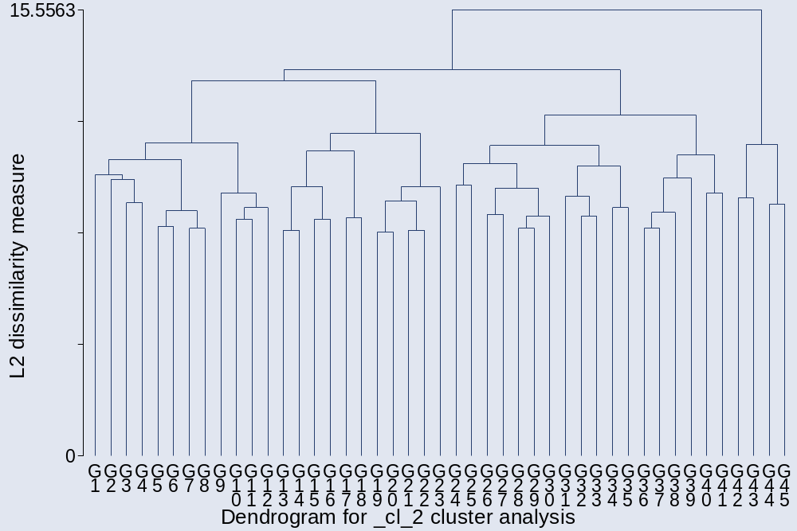

. cluster stop
+---------------------------+
| | Calinski/ |
| Number of | Harabasz |
| clusters | pseudo-F |
|-------------+-------------|
| 2 | 101.64 |
| 3 | 119.16 |
| 4 | 114.01 |
| 5 | 101.97 |
| 6 | 87.29 |
| 7 | 81.16 |
| 8 | 72.38 |
| 9 | 67.68 |
| 10 | 61.53 |
| 11 | 59.03 |
| 12 | 55.28 |
| 13 | 53.51 |
| 14 | 50.07 |
| 15 | 47.47 |
+---------------------------+

. cluster stop, rule (duda)

+-----------------------------------------+
| | Duda/Hart |
| Number of | | pseudo |
| clusters | Je(2)/Je(1) | T-squared |
|-------------+-------------+-------------|
| 1 | 0.9175 | 101.64 |
| 2 | 0.8972 | 126.45 |
| 3 | 0.8275 | 77.57 |
| 4 | 0.9286 | 56.15 |
| 5 | 0.8432 | 16.73 |
| 6 | 0.8822 | 37.39 |
| 7 | 0.6481 | 13.03 |
| 8 | 0.9502 | 26.09 |
| 9 | 0.8563 | 6.71 |
| 10 | 0.8942 | 27.22 |
| 11 | 0.9054 | 8.56 |
| 12 | 0.9313 | 24.34 |
| 13 | 0.9640 | 6.20 |
| 14 | 0.8983 | 6.79 |

| 15 | 0.9453 | 11.51 |
+-----------------------------------------+

Five groups:

. cluster gen gcom5 = group (5)

. bysort gcom5: sum cl*

_______________________________________________________________________________
-> gcom5 = 1

Variable | Obs Mean Std. Dev. Min Max
-------------+--------------------------------------------------------
cltariff | 282 3.287234 1.233769 1 5
clminw | 282 1.659574 1.045783 1 5
clOSHA | 282 1.393617 .69392 1 4
clFDA | 282 1.294326 .6329362 1 4
clEPA | 282 1.294326 .638534 1 4
-------------+--------------------------------------------------------
cldisc | 282 1.546099 1.036523 1 5
cldrugs | 282 1.351064 .7114835 1 5
clprost | 282 2.198582 1.017427 1 5
clgambl | 282 2.074468 1.032283 1 5
clguns | 282 1.755319 1.163069 1 5
-------------+--------------------------------------------------------
clgovown | 282 3.712766 1.239524 1 5
clredist | 282 1.914894 1.156688 1 5
clmonet | 282 1.77305 .8124371 1 5
clfisc | 282 1.847518 .9095055 1 5
climmi | 282 2.29078 1.193333 1 5
-------------+--------------------------------------------------------
clmilaid | 282 2.27305 1.040078 1 5
clWB | 282 1.833333 .9714184 1 5

_______________________________________________________________________________
-> gcom5 = 2

Variable | Obs Mean Std. Dev. Min Max
-------------+--------------------------------------------------------
cltariff | 92 4.630435 .6240138 3 5
clminw | 92 3.282609 1.369415 1 5
clOSHA | 92 2.065217 .9699252 1 4
clFDA | 92 2.26087 1.166092 1 5
clEPA | 92 1.880435 .9239475 1 5
-------------+--------------------------------------------------------
cldisc | 92 1.923913 1.294398 1 5
cldrugs | 92 2.902174 1.391179 1 5
clprost | 92 3.75 1.125381 1 5
clgambl | 92 3.923913 1.018873 1 5
clguns | 92 2.836957 1.513871 1 5
-------------+--------------------------------------------------------
clgovown | 92 4.586957 .8140548 1 5
clredist | 92 2.478261 1.329945 1 5
clmonet | 92 2.119565 1.046631 1 5
clfisc | 92 3 1.300887 1 5
climmi | 92 3.673913 1.310219 1 5
-------------+--------------------------------------------------------
clmilaid | 92 2.684783 1.248554 1 5
clWB | 92 2.25 1.044346 1 5

_______________________________________________________________________________
-> gcom5 = 3

Variable | Obs Mean Std. Dev. Min Max
-------------+--------------------------------------------------------
cltariff | 500 3.518 1.17492 1 5
clminw | 500 1.152 .4661874 1 4
clOSHA | 500 1.15 .4646847 1 4
clFDA | 500 1.264 .6411913 1 5
clEPA | 500 1.054 .2433154 1 3
-------------+--------------------------------------------------------
cldisc | 500 1.186 .5797208 1 5
cldrugs | 500 2.336 1.222331 1 5
clprost | 500 3.034 1.072915 1 5
clgambl | 500 2.338 1.00288 1 5
clguns | 500 1.188 .5525093 1 5
-------------+--------------------------------------------------------
clgovown | 500 3.042 1.226068 1 5
clredist | 500 1.286 .6106962 1 5
clmonet | 500 2.232 .9186206 1 5
clfisc | 500 2.144 .9235637 1 5
climmi | 500 3.908 1.123414 1 5
-------------+--------------------------------------------------------
clmilaid | 500 3.954 1.146522 1 5
clWB | 500 2.19 1.258996 1 5

_______________________________________________________________________________
-> gcom5 = 4

Variable | Obs Mean Std. Dev. Min Max
-------------+--------------------------------------------------------
cltariff | 232 3.590517 1.101159 1 5
clminw | 232 1.125 .433325 1 4
clOSHA | 232 1.056034 .2654046 1 3
clFDA | 232 1.219828 .5087494 1 3
clEPA | 232 1.043103 .2035291 1 2
-------------+--------------------------------------------------------
cldisc | 232 1.099138 .3876884 1 3
cldrugs | 232 3.306034 1.24015 1 5
clprost | 232 4.081897 .8714916 1 5
clgambl | 232 4.00431 .8603726 2 5
clguns | 232 1.366379 .9254875 1 5
-------------+--------------------------------------------------------
clgovown | 232 2.836207 1.13918 1 5
clredist | 232 1.271552 .6509807 1 5
clmonet | 232 2.099138 .9321572 1 5
clfisc | 232 1.965517 .8820581 1 5
climmi | 232 3.681034 1.358629 1 5
-------------+--------------------------------------------------------
clmilaid | 232 3.693966 1.298136 1 5
clWB | 232 2.189655 1.305425 1 5

A libertarian group:
_______________________________________________________________________________
-> gcom5 = 5

Variable | Obs Mean Std. Dev. Min Max
-------------+--------------------------------------------------------
cltariff | 26 4.730769 .8274149 1 5
clminw | 26 4.730769 .4523443 4 5
clOSHA | 26 4.230769 .8152395 3 5
clFDA | 26 4.384615 .752432 3 5
clEPA | 26 4.115385 .863802 2 5
-------------+--------------------------------------------------------
cldisc | 26 3.615385 1.387859 1 5
cldrugs | 26 3.5 1.679286 1 5
clprost | 26 3.923077 1.598076 1 5
clgambl | 26 4.038462 1.509457 1 5
clguns | 26 4.769231 .6516252 2 5
-------------+--------------------------------------------------------
clgovown | 26 4.884615 .3258126 4 5
clredist | 26 4.307692 .970329 2 5
clmonet | 26 3.653846 1.263085 1 5
clfisc | 26 4.115385 1.142871 2 5
climmi | 26 3.384615 1.651107 1 5
-------------+--------------------------------------------------------
clmilaid | 26 2.884615 1.608152 1 5
clWB | 26 4.076923 1.293772 1 5

Those with missing values:
_______________________________________________________________________________
-> gcom5 = .

Variable | Obs Mean Std. Dev. Min Max
-------------+--------------------------------------------------------
cltariff | 68 3.544118 1.125469 1 5
clminw | 72 1.194444 .4638749 1 3
clOSHA | 72 1.194444 .5725871 1 4
clFDA | 71 1.366197 .7971276 1 5
clEPA | 70 1.171429 .5376122 1 4
-------------+--------------------------------------------------------
cldisc | 72 1.263889 .6498766 1 4
cldrugs | 66 2.545455 1.41619 1 5
clprost | 67 3.134328 1.192089 1 5
clgambl | 67 2.492537 1.259788 1 5
clguns | 68 1.323529 .9374652 1 5
-------------+--------------------------------------------------------
clgovown | 59 3.220339 1.339941 1 5
clredist | 62 1.387097 .9117599 1 5
clmonet | 64 2 .9594972 1 5
clfisc | 70 1.942857 .8990448 1 5
climmi | 73 3.69863 1.298342 1 5
-------------+--------------------------------------------------------
clmilaid | 56 3.571429 1.450481 1 5
clWB | 69 2.130435 1.247504 1 5

The second analysis uses Average Linkage clustering, same subsample: all policy items are included.

. cluster averagelinkage cl*
cluster name: _cl_1

. cluster tree, vertlab cutnumber (40)

. cluster stop

+---------------------------+
| | Calinski/ |
| Number of | Harabasz |
| clusters | pseudo-F |
|-------------+-------------|
| 2 | 157.99 |
| 3 | 81.39 |
| 4 | 63.39 |
| 5 | 48.04 |
| 6 | 39.90 |
| 7 | 34.65 |
| 8 | 30.03 |
| 9 | 27.11 |
| 10 | 24.77 |
| 11 | 22.77 |
| 12 | 26.06 |
| 13 | 24.20 |
| 14 | 22.64 |
| 15 | 21.29 |
+---------------------------+

. cluster stop, rule (duda)

+-----------------------------------------+
| | Duda/Hart |
| Number of | | pseudo |
| clusters | Je(2)/Je(1) | T-squared |
|-------------+-------------+-------------|
| 1 | 0.8701 | 157.99 |
| 2 | 0.9956 | 4.43 |
| 3 | 0.7269 | 21.04 |
| 4 | 0.0000 | . |
| 5 | 0.9936 | 6.44 |
| 6 | 0.7842 | 8.81 |
| 7 | 0.4817 | 2.15 |
| 8 | 0.8139 | 5.03 |
| 9 | 0.9948 | 5.16 |
| 10 | 0.9959 | 4.08 |
| 11 | 0.9531 | 48.65 |
| 12 | 0.8560 | 2.86 |
| 13 | 0.9440 | 2.73 |
| 14 | 0.8749 | 4.01 |
| 15 | 0.6071 | 1.94 |
+-----------------------------------------+

Seven Groups;

. cluster gen gav7=group (7)

. bysort gav7: sum cl*

_______________________________________________________________________________
-> gav7 = 1

Variable | Obs Mean Std. Dev. Min Max
-------------+--------------------------------------------------------
cltariff | 24 3.041667 1.334465 1 5
clminw | 24 3.166667 1.434563 1 5
clOSHA | 24 2.458333 1.062367 1 4
clFDA | 24 2.625 1.095941 1 4
clEPA | 24 2.333333 1.129319 1 4
-------------+--------------------------------------------------------
cldisc | 24 2.708333 1.545798 1 5
cldrugs | 24 2.416667 1.691839 1 5
clprost | 24 3.166667 1.34056 1 5
clgambl | 24 3.25 1.421879 1 5
clguns | 24 3.583333 1.44212 1 5
-------------+--------------------------------------------------------
clgovown | 24 4.458333 .8329709 3 5
clredist | 24 4.166667 .8681147 2 5
clschool | 24 3.541667 1.318074 1 5
clmonet | 24 2.583333 .9743076 1 4
clfisc | 24 2.416667 .8805466 1 4
-------------+--------------------------------------------------------
climmi | 24 1.541667 .72106 1 3
clmilaid | 24 1.625 .9237212 1 4
clWB | 24 2.375 1.055524 1 4

A libertarian group:
_______________________________________________________________________________
-> gav7 = 2

Variable | Obs Mean Std. Dev. Min Max
-------------+--------------------------------------------------------
cltariff | 30 4.8 .7611244 1 5
clminw | 30 4.733333 .4497764 4 5
clOSHA | 30 4.066667 .7849153 3 5
clFDA | 30 4.2 .8866831 3 5
clEPA | 30 3.8 .9247553 2 5
-------------+--------------------------------------------------------
cldisc | 30 3.566667 1.304722 1 5
cldrugs | 30 4.2 .8866831 2 5
clprost | 30 4.6 .5632418 3 5
clgambl | 30 4.666667 .6064784 3 5
clguns | 30 4.766667 .5040069 3 5
-------------+--------------------------------------------------------
clgovown | 30 4.933333 .2537081 4 5
clredist | 30 4.266667 .9444332 2 5
clschool | 30 4.433333 .7738544 2 5
clmonet | 30 3.4 1.302517 1 5
clfisc | 30 4.3 .9153857 2 5
-------------+--------------------------------------------------------
climmi | 30 3.533333 1.525266 1 5
clmilaid | 30 3.233333 1.356551 1 5
clWB | 30 4.1 .922889 3 5

_______________________________________________________________________________
-> gav7 = 3

Variable | Obs Mean Std. Dev. Min Max
-------------+--------------------------------------------------------
cltariff | 4 4.75 .5 4 5
clminw | 4 4.75 .5 4 5
clOSHA | 4 4 1.154701 3 5
clFDA | 4 4 .8164966 3 5
clEPA | 4 4.25 .9574271 3 5
-------------+--------------------------------------------------------
cldisc | 4 4.5 .5773503 4 5
cldrugs | 4 1 0 1 1
clprost | 4 1 0 1 1
clgambl | 4 1.25 .5 1 2
clguns | 4 5 0 5 5
-------------+--------------------------------------------------------
clgovown | 4 4.75 .5 4 5
clredist | 4 4.5 .5773503 4 5
clschool | 4 3.25 1.707825 1 5
clmonet | 4 4.25 .9574271 3 5
clfisc | 4 4 1.414214 2 5
-------------+--------------------------------------------------------
climmi | 4 3.75 1.892969 1 5
clmilaid | 4 2.25 1.892969 1 5
clWB | 4 3.5 1.290994 2 5

_______________________________________________________________________________
-> gav7 = 4

Variable | Obs Mean Std. Dev. Min Max
-------------+--------------------------------------------------------
cltariff | 996 3.564257 1.187408 1 5
clminw | 996 1.401606 .8747476 1 5
clOSHA | 996 1.225904 .5510809 1 4
clFDA | 996 1.292169 .6419027 1 5
clEPA | 996 1.146586 .4399616 1 5
-------------+--------------------------------------------------------
cldisc | 996 1.26004 .7057905 1 5
cldrugs | 996 2.316265 1.305334 1 5
clprost | 996 3.092369 1.221047 1 5
clgambl | 996 2.728916 1.258062 1 5
clguns | 996 1.428715 .9187816 1 5
-------------+--------------------------------------------------------
clgovown | 996 3.24498 1.28236 1 5
clredist | 996 1.450803 .8098572 1 5
clschool | 996 1.588353 1.003123 1 5
clmonet | 996 2.041165 .9018753 1 5
clfisc | 996 2.067269 .958691 1 5
-------------+--------------------------------------------------------
climmi | 996 3.476908 1.365942 1 5
clmilaid | 996 3.414659 1.350133 1 5
clWB | 996 2.089357 1.1917 1 5

_______________________________________________________________________________
-> gav7 = 5

Variable | Obs Mean Std. Dev. Min Max
-------------+--------------------------------------------------------
cltariff | 4 2.5 1 1 3
clminw | 4 1 0 1 1
clOSHA | 4 1 0 1 1
clFDA | 4 1.25 .5 1 2
clEPA | 4 1 0 1 1
-------------+--------------------------------------------------------
cldisc | 4 2.5 1.914854 1 5
cldrugs | 4 2.75 1.258306 1 4
clprost | 4 3.5 .5773503 3 4
clgambl | 4 3.5 1.290994 2 5
clguns | 4 1 0 1 1
-------------+--------------------------------------------------------
clgovown | 4 3.25 1.258306 2 5
clredist | 4 4.25 .9574271 3 5
clschool | 4 4 2 1 5
clmonet | 4 4.25 1.5 2 5
clfisc | 4 4.5 1 3 5
-------------+--------------------------------------------------------
climmi | 4 4 2 1 5
clmilaid | 4 5 0 5 5
clWB | 4 2.25 1.892969 1 5

_______________________________________________________________________________
-> gav7 = 6

Variable | Obs Mean Std. Dev. Min Max
-------------+--------------------------------------------------------
cltariff | 1 4 . 4 4
clminw | 1 1 . 1 1
clOSHA | 1 1 . 1 1
clFDA | 1 5 . 5 5
clEPA | 1 1 . 1 1
-------------+--------------------------------------------------------
cldisc | 1 1 . 1 1
cldrugs | 1 5 . 5 5
clprost | 1 4 . 4 4
clgambl | 1 4 . 4 4
clguns | 1 5 . 5 5
-------------+--------------------------------------------------------
clgovown | 1 5 . 5 5
clredist | 1 2 . 2 2
clschool | 1 1 . 1 1
clmonet | 1 3 . 3 3
clfisc | 1 3 . 3 3
-------------+--------------------------------------------------------
climmi | 1 5 . 5 5
clmilaid | 1 5 . 5 5
clWB | 1 5 . 5 5

_______________________________________________________________________________
-> gav7 = 7

Variable | Obs Mean Std. Dev. Min Max
-------------+--------------------------------------------------------
cltariff | 1 5 . 5 5
clminw | 1 1 . 1 1
clOSHA | 1 1 . 1 1
clFDA | 1 5 . 5 5
clEPA | 1 1 . 1 1
-------------+--------------------------------------------------------
cldisc | 1 1 . 1 1
cldrugs | 1 1 . 1 1
clprost | 1 5 . 5 5
clgambl | 1 1 . 1 1
clguns | 1 1 . 1 1
-------------+--------------------------------------------------------
clgovown | 1 3 . 3 3
clredist | 1 1 . 1 1
clschool | 1 5 . 5 5
clmonet | 1 5 . 5 5
clfisc | 1 5 . 5 5
-------------+--------------------------------------------------------
climmi | 1 5 . 5 5
clmilaid | 1 5 . 5 5
clWB | 1 5 . 5 5

Those with missing values:
_______________________________________________________________________________
-> gav7 = .

Variable | Obs Mean Std. Dev. Min Max
-------------+--------------------------------------------------------
cltariff | 140 3.6 1.098069 1 5
clminw | 144 1.229167 .6554639 1 5
clOSHA | 144 1.215278 .5440485 1 4
clFDA | 143 1.342657 .7515701 1 5
clEPA | 142 1.133803 .4492527 1 4
-------------+--------------------------------------------------------
cldisc | 144 1.3125 .7523274 1 5
cldrugs | 138 2.391304 1.400911 1 5
clprost | 139 3.021583 1.20065 1 5
clgambl | 139 2.561151 1.222465 1 5
clguns | 140 1.421429 .9896432 1 5
-------------+--------------------------------------------------------
clgovown | 131 3.343511 1.275636 1 5
clredist | 134 1.440299 .8801161 1 5
clschool | 60 1.533333 .9994349 1 5
clmonet | 136 2.073529 .9078453 1 5
clfisc | 142 1.971831 .9297576 1 5
-------------+--------------------------------------------------------
climmi | 145 3.468966 1.328403 1 5
clmilaid | 128 3.289063 1.437147 1 5
clWB | 141 2.028369 1.194889 1 5

The same analysis with Complete Linkage clustering but where the schooling item is dropped:

. drop clschool
. cluster averagelinkage cl*
cluster name: _cl_2
. cluster tree, vertlab cutnumber (40)
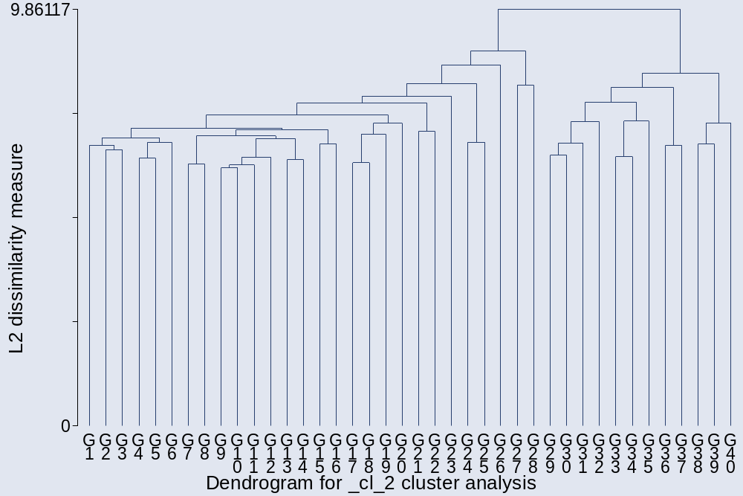

. cluster stop

+---------------------------+
| | Calinski/ |
| Number of | Harabasz |
| clusters | pseudo-F |
|-------------+-------------|
| 2 | 161.25 |
| 3 | 83.31 |
| 4 | 56.63 |
| 5 | 45.08 |
| 6 | 36.96 |
| 7 | 31.11 |
| 8 | 27.66 |
| 9 | 24.53 |
| 10 | 23.15 |
| 11 | 21.33 |
| 12 | 21.86 |
| 13 | 20.30 |
| 14 | 18.90 |
| 15 | 17.70 |
+---------------------------+

. cluster stop, rule (duda)

+-----------------------------------------+
| | Duda/Hart |
| Number of | | pseudo |
| clusters | Je(2)/Je(1) | T-squared |
|-------------+-------------+-------------|
| 1 | 0.8751 | 161.25 |
| 2 | 0.9954 | 4.91 |
| 3 | 0.9972 | 3.03 |
| 4 | 0.8773 | 7.56 |
| 5 | 0.9963 | 4.03 |
| 6 | 0.0000 | . |
| 7 | 0.9002 | 5.32 |
| 8 | 0.9977 | 2.41 |
| 9 | 0.7990 | 11.07 |
| 10 | 0.9960 | 4.28 |
| 11 | 0.9789 | 22.97 |
| 12 | 0.6891 | 3.16 |
| 13 | 0.9415 | 2.18 |
| 14 | 0.6700 | 1.97 |
| 15 | 0.8785 | 2.90 |
+-----------------------------------------+

Three groups:

. cluster gen gav3=group(3)
. bysort gav3: sum cl*
______________________________________________________________________________
-> gav3 = 1

Variable | Obs Mean Std. Dev. Min Max
-------------+--------------------------------------------------------
cltariff | 1074 3.529795 1.182959 1 5
clminw | 1074 1.36406 .8092272 1 5
clOSHA | 1074 1.22067 .5398397 1 4
clFDA | 1074 1.302607 .6552197 1 5
clEPA | 1074 1.142458 .4308728 1 4
-------------+--------------------------------------------------------
cldisc | 1074 1.272812 .7269708 1 5
cldrugs | 1074 2.3054 1.313004 1 5
clprost | 1074 3.070764 1.215243 1 5
clgambl | 1074 2.707635 1.246878 1 5
clguns | 1074 1.450652 .9575737 1 5
-------------+--------------------------------------------------------
clgovown | 1074 3.253259 1.273837 1 5
clredist | 1074 1.489758 .879712 1 5
clmonet | 1074 2.065177 .9073777 1 5
clfisc | 1074 2.049348 .9341729 1 5
climmi | 1074 3.439479 1.379711 1 5
-------------+--------------------------------------------------------
clmilaid | 1074 3.382682 1.366528 1 5
clWB | 1074 2.083799 1.193512 1 5

_______________________________________________________________________________
-> gav3 = 2

Variable | Obs Mean Std. Dev. Min Max
-------------+--------------------------------------------------------
cltariff | 2 5 0 5 5
clminw | 2 5 0 5 5
clOSHA | 2 2 1.414214 1 3
clFDA | 2 1.5 .7071068 1 2
clEPA | 2 1.5 .7071068 1 2
-------------+--------------------------------------------------------
cldisc | 2 3 2.828427 1 5
cldrugs | 2 1 0 1 1
clprost | 2 1 0 1 1
clgambl | 2 1.5 .7071068 1 2
clguns | 2 1 0 1 1
-------------+--------------------------------------------------------
clgovown | 2 5 0 5 5
clredist | 2 5 0 5 5
clmonet | 2 1 0 1 1
clfisc | 2 3 2.828427 1 5
climmi | 2 2.5 .7071068 2 3
-------------+--------------------------------------------------------
clmilaid | 2 3 2.828427 1 5
clWB | 2 2.5 2.12132 1 4

A fairly libertarian group:
_______________________________________________________________________________
-> gav3 = 3

Variable | Obs Mean Std. Dev. Min Max
-------------+--------------------------------------------------------
cltariff | 56 4.767857 .6603325 1 5
clminw | 56 4.553571 .736568 1 5
clOSHA | 56 3.535714 1.078118 1 5
clFDA | 56 3.571429 1.346472 1 5
clEPA | 56 3.285714 1.246293 1 5
-------------+--------------------------------------------------------
cldisc | 56 3.25 1.467837 1 5
cldrugs | 56 3.5 1.452271 1 5
clprost | 56 4.125 1.191828 1 5
clgambl | 56 4.25 1.148121 1 5
clguns | 56 4.125 1.280092 1 5
-------------+--------------------------------------------------------
clgovown | 56 4.839286 .4583284 3 5
clredist | 56 3.714286 1.289317 1 5
clmonet | 56 3.089286 1.391883 1 5
clfisc | 56 4.017857 1.151932 1 5
climmi | 56 3.232143 1.560782 1 5
-------------+--------------------------------------------------------
clmilaid | 56 2.821429 1.41559 1 5
clWB | 56 3.392857 1.302844 1 5

Those with missing values:
_______________________________________________________________________________
-> gav3 = .

Variable | Obs Mean Std. Dev. Min Max
-------------+--------------------------------------------------------
cltariff | 68 3.544118 1.125469 1 5
clminw | 72 1.194444 .4638749 1 3
clOSHA | 72 1.194444 .5725871 1 4
clFDA | 71 1.366197 .7971276 1 5
clEPA | 70 1.171429 .5376122 1 4
-------------+--------------------------------------------------------
cldisc | 72 1.263889 .6498766 1 4
cldrugs | 66 2.545455 1.41619 1 5
clprost | 67 3.134328 1.192089 1 5
clgambl | 67 2.492537 1.259788 1 5
clguns | 68 1.323529 .9374652 1 5
-------------+--------------------------------------------------------
clgovown | 59 3.220339 1.339941 1 5
clredist | 62 1.387097 .9117599 1 5
clmonet | 64 2 .9594972 1 5
clfisc | 70 1.942857 .8990448 1 5
climmi | 73 3.69863 1.298342 1 5
-------------+--------------------------------------------------------
clmilaid | 56 3.571429 1.450481 1 5
clWB | 69 2.130435 1.247504 1 5

The third analysis uses Wards Linkage clustering:

. cluster wardslinkage cl*
cluster name: _cl_1

. cluster tree, vertlab cutnumber (40)
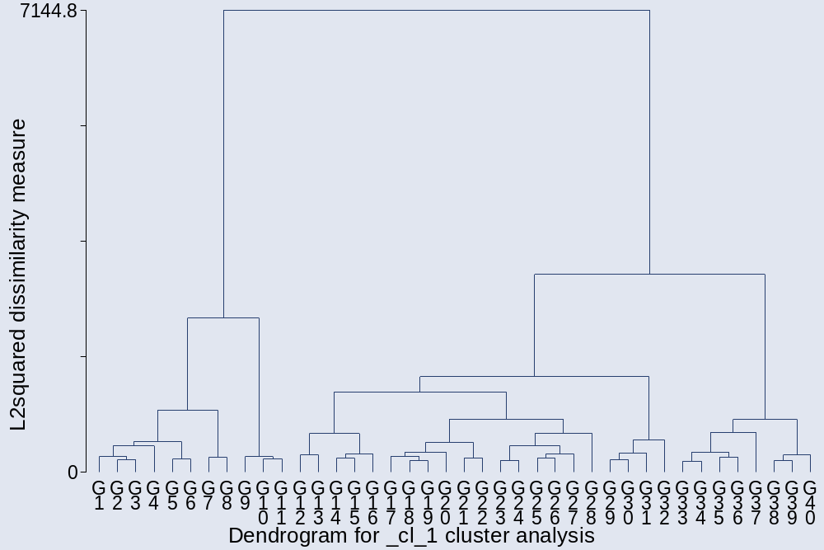

. cluster stop

+---------------------------+
| | Calinski/ |
| Number of | Harabasz |
| clusters | pseudo-F |
|-------------+-------------|
| 2 | 180.81 |
| 3 | 139.10 |
| 4 | 121.78 |
| 5 | 106.21 |
| 6 | 95.80 |
| 7 | 87.21 |
| 8 | 80.47 |
| 9 | 75.61 |
| 10 | 70.88 |
| 11 | 67.13 |
| 12 | 64.16 |
| 13 | 61.28 |
| 14 | 58.76 |
| 15 | 56.66 |
+---------------------------+

. cluster stop, rule (duda)

+-----------------------------------------+
| | Duda/Hart |
| Number of | | pseudo |
| clusters | Je(2)/Je(1) | T-squared |
|-------------+-------------+-------------|
| 1 | 0.8540 | 180.81 |
| 2 | 0.9030 | 96.09 |
| 3 | 0.7686 | 48.46 |
| 4 | 0.9297 | 46.66 |
| 5 | 0.9214 | 40.24 |
| 6 | 0.8519 | 21.21 |
| 7 | 0.9204 | 31.72 |
| 8 | 0.8922 | 33.33 |
| 9 | 0.8599 | 27.21 |
| 10 | 0.8846 | 28.95 |
| 11 | 0.8597 | 16.81 |
| 12 | 0.8636 | 22.60 |
| 13 | 0.8888 | 11.13 |
| 14 | 0.8919 | 17.33 |
| 15 | 0.8920 | 21.79 |
+-----------------------------------------+

Five groups:

. cluster gen gward5= group(5)
. bysort gward5: sum cl*

_______________________________________________________________________________
-> gward5 = 1

Variable | Obs Mean Std. Dev. Min Max
-------------+--------------------------------------------------------
cltariff | 124 3.887097 1.263687 1 5
clminw | 124 3.032258 1.390651 1 5
clOSHA | 124 2.056452 .9396628 1 5
clFDA | 124 1.870968 .987464 1 5
clEPA | 124 1.919355 .9335375 1 5
-------------+--------------------------------------------------------
cldisc | 124 2.129032 1.2095 1 5
cldrugs | 124 1.943548 1.28975 1 5
clprost | 124 2.774194 1.395922 1 5
clgambl | 124 2.733871 1.420574 1 5
clguns | 124 2.75 1.48502 1 5
-------------+--------------------------------------------------------
clgovown | 124 4.467742 .8403975 2 5
clredist | 124 3.008065 1.239564 1 5
clschool | 124 2.669355 1.311127 1 5
clmonet | 124 2.137097 1.006763 1 5
clfisc | 124 2.516129 1.185851 1 5
-------------+--------------------------------------------------------
climmi | 124 2.524194 1.38789 1 5
clmilaid | 124 2.370968 1.143861 1 5
clWB | 124 2.241935 1.023075 1 5

A libertarian group:
_______________________________________________________________________________
-> gward5 = 2

Variable | Obs Mean Std. Dev. Min Max
-------------+--------------------------------------------------------
cltariff | 39 4.820513 .6833276 1 5
clminw | 39 4.538462 .6002698 3 5
clOSHA | 39 3.871795 .8638801 2 5
clFDA | 39 4.128205 .8328609 3 5
clEPA | 39 3.641026 .9864124 2 5
-------------+--------------------------------------------------------
cldisc | 39 3.333333 1.456986 1 5
cldrugs | 39 4.128205 .9508857 2 5
clprost | 39 4.538462 .6002698 3 5

clgambl | 39 4.641026 .6277436 3 5
clguns | 39 4.410256 1.044231 1 5
-------------+--------------------------------------------------------
clgovown | 39 4.923077 .2699528 4 5
clredist | 39 3.948718 1.168641 1 5
clschool | 39 3.923077 1.243607 1 5
clmonet | 39 3.102564 1.333671 1 5
clfisc | 39 4.102564 .9945872 2 5
-------------+--------------------------------------------------------
climmi | 39 3.487179 1.536774 1 5
clmilaid | 39 3 1.395481 1 5
clWB | 39 3.820513 1.048101 2 5

_______________________________________________________________________________
-> gward5 = 3

Variable | Obs Mean Std. Dev. Min Max
-------------+--------------------------------------------------------
cltariff | 474 3.417722 1.228013 1 5
clminw | 474 1.257384 .6314505 1 5
clOSHA | 474 1.14557 .4137073 1 3
clFDA | 474 1.2173 .5374321 1 4
clEPA | 474 1.059072 .2615048 1 3
-------------+--------------------------------------------------------
cldisc | 474 1.274262 .7698686 1 5
cldrugs | 474 1.757384 .991613 1 5
clprost | 474 2.582278 1.114285 1 5
clgambl | 474 2.198312 1.071797 1 5
clguns | 474 1.339662 .7941572 1 5
-------------+--------------------------------------------------------
clgovown | 474 3.272152 1.240518 1 5
clredist | 474 1.417722 .7460837 1 5
clschool | 474 1.7173 1.13945 1 5
clmonet | 474 1.993671 .9138134 1 5
clfisc | 474 2.040084 .9312957 1 5
-------------+--------------------------------------------------------
climmi | 474 3.318565 1.345965 1 5
clmilaid | 474 3.223629 1.271159 1 5
clWB | 474 1.894515 1.075113 1 5

_______________________________________________________________________________
-> gward5 = 4

Variable | Obs Mean Std. Dev. Min Max
-------------+--------------------------------------------------------
cltariff | 145 3.965517 .945852 1 5
clminw | 145 1.289655 .576354 1 3
clOSHA | 145 1.110345 .3558488 1 3
clFDA | 145 1.17931 .4513708 1 3
clEPA | 145 1.089655 .3099561 1 3
-------------+--------------------------------------------------------
cldisc | 145 1.151724 .4762562 1 4
cldrugs | 145 2.82069 1.294588 1 5
clprost | 145 3.758621 .9374601 1 5
clgambl | 145 3.641379 .9977465 1 5

clguns | 145 1.275862 .6399084 1 4
-------------+--------------------------------------------------------
clgovown | 145 3.241379 1.281687 1 5
clredist | 145 1.303448 .556828 1 3
clschool | 145 1.213793 .5294941 1 4
clmonet | 145 1.641379 .6939807 1 4
clfisc | 145 1.551724 .716192 1 4
-------------+--------------------------------------------------------
climmi | 145 2.834483 1.384506 1 5
clmilaid | 145 2.475862 1.099765 1 5
clWB | 145 1.365517 .6750905 1 4

_______________________________________________________________________________
-> gward5 = 5

Variable | Obs Mean Std. Dev. Min Max
-------------+--------------------------------------------------------
cltariff | 278 3.381295 1.133001 1 5
clminw | 278 1.089928 .3221756 1 3
clOSHA | 278 1.129496 .4549691 1 4
clFDA | 278 1.316547 .7213702 1 5
clEPA | 278 1.061151 .2684387 1 3
-------------+--------------------------------------------------------
cldisc | 278 1.05036 .2772672 1 4
cldrugs | 278 3.122302 1.282824 1 5
clprost | 278 3.708633 .9898388 1 5
clgambl | 278 3.129496 1.173317 1 5
clguns | 278 1.255396 .7525334 1 5
-------------+--------------------------------------------------------
clgovown | 278 2.733813 1.156214 1 5
clredist | 278 1.161871 .4796051 1 3
clschool | 278 1.298561 .6750302 1 5
clmonet | 278 2.410072 .9254754 1 5
clfisc | 278 2.244604 .9256999 1 5
-------------+--------------------------------------------------------
climmi | 278 4.366906 .8294567 1 5
clmilaid | 278 4.597122 .7281788 1 5
clWB | 278 2.773381 1.344494 1 5

Those with missing values:
_______________________________________________________________________________
-> gward5 = .

Variable | Obs Mean Std. Dev. Min Max
-------------+--------------------------------------------------------
cltariff | 140 3.6 1.098069 1 5
clminw | 144 1.229167 .6554639 1 5
clOSHA | 144 1.215278 .5440485 1 4
clFDA | 143 1.342657 .7515701 1 5
clEPA | 142 1.133803 .4492527 1 4
-------------+--------------------------------------------------------
cldisc | 144 1.3125 .7523274 1 5
cldrugs | 138 2.391304 1.400911 1 5
clprost | 139 3.021583 1.20065 1 5
clgambl | 139 2.561151 1.222465 1 5
clguns | 140 1.421429 .9896432 1 5

-------------+--------------------------------------------------------
clgovown | 131 3.343511 1.275636 1 5
clredist | 134 1.440299 .8801161 1 5
clschool | 60 1.533333 .9994349 1 5
clmonet | 136 2.073529 .9078453 1 5
clfisc | 142 1.971831 .9297576 1 5
-------------+--------------------------------------------------------
climmi | 145 3.468966 1.328403 1 5
clmilaid | 128 3.289063 1.437147 1 5
clWB | 141 2.028369 1.194889 1 5

The same analysis using Wards Linkage clustering but with the schooling question dropped:

. drop clschool
. cluster wardslinkage cl*
cluster name: _cl_2

. cluster tree, vertlab cutnumber (40)
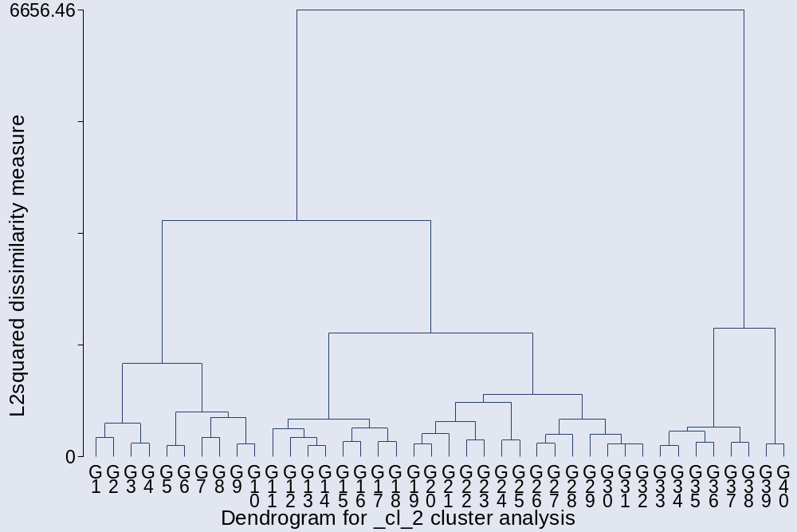

. cluster stop
+---------------------------+
| | Calinski/ |
| Number of | Harabasz |
| clusters | pseudo-F |
|-------------+-------------|
| 2 | 178.82 |
| 3 | 148.98 |
| 4 | 124.07 |
| 5 | 112.79 |
| 6 | 103.27 |
| 7 | 93.82 |
| 8 | 86.52 |
| 9 | 80.25 |
| 10 | 75.05 |
| 11 | 70.87 |
| 12 | 67.53 |
| 13 | 64.66 |
| 14 | 62.19 |
| 15 | 59.87 |
+---------------------------+

. cluster stop, rule (duda)
+-----------------------------------------+
| | Duda/Hart |
| Number of | | pseudo |
| clusters | Je(2)/Je(1) | T-squared |
|-------------+-------------+-------------|
| 1 | 0.8634 | 178.82 |
| 2 | 0.9009 | 111.92 |
| 3 | 0.7082 | 45.33 |
| 4 | 0.9154 | 65.68 |
| 5 | 0.8641 | 47.97 |
| 6 | 0.9298 | 36.49 |
| 7 | 0.8906 | 34.88 |
| 8 | 0.8657 | 27.61 |
| 9 | 0.8182 | 26.22 |
| 10 | 0.9157 | 20.80 |
| 11 | 0.8866 | 25.19 |
| 12 | 0.8948 | 24.69 |
| 13 | 0.8723 | 18.30 |
| 14 | 0.8763 | 10.59 |
| 15 | 0.8642 | 21.53 |
+-----------------------------------------+

Five groups:

. cluster gen gw5= group (5)
. bysort gw5: sum cl*

_______________________________________________________________________________
-> gw5 = 1

Variable | Obs Mean Std. Dev. Min Max
-------------+--------------------------------------------------------
cltariff | 307 3.442997 1.165619 1 5
clminw | 307 1.309446 .8315719 1 5
clOSHA | 307 1.13355 .4483974 1 4
clFDA | 307 1.37785 .7799979 1 5
clEPA | 307 1.114007 .3919524 1 5
-------------+--------------------------------------------------------
cldisc | 307 1.166124 .6480935 1 5
cldrugs | 307 3.211726 1.295086 1 5
clprost | 307 3.762215 1.090125 1 5
clgambl | 307 3.283388 1.28636 1 5
clguns | 307 1.390879 .9201706 1 5
-------------+--------------------------------------------------------
clgovown | 307 2.827362 1.241771 1 5
clredist | 307 1.299674 .6870177 1 5
clmonet | 307 2.465798 .9189204 1 5
clfisc | 307 2.498371 .9880812 1 5
climmi | 307 3.928339 1.231959 1 5
-------------+--------------------------------------------------------
clmilaid | 307 4.482085 .8831233 1 5
clWB | 307 2.95114 1.328751 1 5

_______________________________________________________________________________
-> gw5 = 2

Variable | Obs Mean Std. Dev. Min Max
-------------+--------------------------------------------------------
cltariff | 228 3.092105 1.225762 1 5
clminw | 228 1.5 .8929484 1 4
clOSHA | 228 1.333333 .6592836 1 4
clFDA | 228 1.232456 .5419813 1 4
clEPA | 228 1.166667 .4582415 1 4
-------------+--------------------------------------------------------
cldisc | 228 1.451754 .9350476 1 5
cldrugs | 228 1.482456 .8677527 1 5
clprost | 228 2.219298 1.088658 1 5
clgambl | 228 1.95614 .969948 1 5
clguns | 228 1.377193 .7437297 1 5
-------------+--------------------------------------------------------
clgovown | 228 3.491228 1.192824 1 5
clredist | 228 1.75 .9726434 1 5
clmonet | 228 1.763158 .8374771 1 5
clfisc | 228 1.785088 .8195553 1 5
climmi | 228 2.403509 1.196318 1 5
-------------+--------------------------------------------------------

clmilaid | 228 2.337719 1.034633 1 5
clWB | 228 1.789474 .9523787 1 5

_______________________________________________________________________________
-> gw5 = 3

Variable | Obs Mean Std. Dev. Min Max
-------------+--------------------------------------------------------
cltariff | 485 3.795876 1.080243 1 5
clminw | 485 1.181443 .468056 1 4
clOSHA | 485 1.148454 .4437615 1 4
clFDA | 485 1.235052 .5699139 1 4
clEPA | 485 1.057732 .2586659 1 3
-------------+--------------------------------------------------------
cldisc | 485 1.17732 .4994843 1 4
cldrugs | 485 2.193814 1.188601 1 5
clprost | 485 3.113402 1.080215 1 5
clgambl | 485 2.736082 1.167942 1 5
clguns | 485 1.265979 .6873843 1 5
-------------+--------------------------------------------------------
clgovown | 485 3.270103 1.251129 1 5
clredist | 485 1.261856 .5525006 1 4
clmonet | 485 1.962887 .8592376 1 5
clfisc | 485 1.880412 .8394507 1 5
climmi | 485 3.787629 1.184547 1 5
-------------+--------------------------------------------------------
clmilaid | 485 3.346392 1.247979 1 5
clWB | 485 1.645361 .88257 1 5

_______________________________________________________________________________
-> gw5 = 4

Variable | Obs Mean Std. Dev. Min Max
-------------+--------------------------------------------------------
cltariff | 77 3.844156 1.308524 1 5
clminw | 77 3.246753 1.39695 1 5
clOSHA | 77 2.142857 .913557 1 5
clFDA | 77 1.987013 1.057473 1 5
clEPA | 77 2.142857 1.035098 1 5
-------------+--------------------------------------------------------
cldisc | 77 2.298701 1.433297 1 5
cldrugs | 77 1.766234 1.050014 1 5
clprost | 77 2.571429 1.1968 1 5
clgambl | 77 2.636364 1.223768 1 5
clguns | 77 3.597403 1.280006 1 5
-------------+--------------------------------------------------------
clgovown | 77 4.571429 .7509393 3 5
clredist | 77 3.441558 1.141254 1 5
clmonet | 77 2.233766 1.098996 1 5
clfisc | 77 2.571429 1.33208 1 5
climmi | 77 2.12987 1.301322 1 5
-------------+--------------------------------------------------------
clmilaid | 77 2.025974 1.038395 1 5
clWB | 77 2.415584 1.139606 1 5

A libertarian group:
_______________________________________________________________________________
-> gw5 = 5

Variable | Obs Mean Std. Dev. Min Max
-------------+--------------------------------------------------------
cltariff | 35 4.828571 .7065123 1 5
clminw | 35 4.657143 .481594 4 5
clOSHA | 35 3.971429 .8219673 2 5
clFDA | 35 4.171429 .8570028 3 5
clEPA | 35 3.657143 .9684086 2 5
-------------+--------------------------------------------------------
cldisc | 35 3.371429 1.373825 1 5
cldrugs | 35 4.285714 .8599394 2 5
clprost | 35 4.628571 .5469549 3 5
clgambl | 35 4.714286 .572478 3 5
clguns | 35 4.542857 .9185301 1 5
-------------+--------------------------------------------------------
clgovown | 35 4.942857 .2355041 4 5
clredist | 35 4.085714 1.039554 2 5
clmonet | 35 3.142857 1.396274 1 5
clfisc | 35 4.228571 .9420164 2 5
climmi | 35 3.571429 1.480972 1 5
-------------+--------------------------------------------------------
clmilaid | 35 3.114286 1.300937 1 5
clWB | 35 3.857143 1.061155 2 5

Those with missing values:
_______________________________________________________________________________
-> gw5 = .

Variable | Obs Mean Std. Dev. Min Max
-------------+--------------------------------------------------------
cltariff | 68 3.544118 1.125469 1 5
clminw | 72 1.194444 .4638749 1 3
clOSHA | 72 1.194444 .5725871 1 4
clFDA | 71 1.366197 .7971276 1 5
clEPA | 70 1.171429 .5376122 1 4
-------------+--------------------------------------------------------
cldisc | 72 1.263889 .6498766 1 4
cldrugs | 66 2.545455 1.41619 1 5
clprost | 67 3.134328 1.192089 1 5
clgambl | 67 2.492537 1.259788 1 5
clguns | 68 1.323529 .9374652 1 5
-------------+--------------------------------------------------------
clgovown | 59 3.220339 1.339941 1 5
clredist | 62 1.387097 .9117599 1 5
clmonet | 64 2 .9594972 1 5
clfisc | 70 1.942857 .8990448 1 5
climmi | 73 3.69863 1.298342 1 5
-------------+--------------------------------------------------------
clmilaid | 56 3.571429 1.450481 1 5
clWB | 69 2.130435 1.247504 1 5

